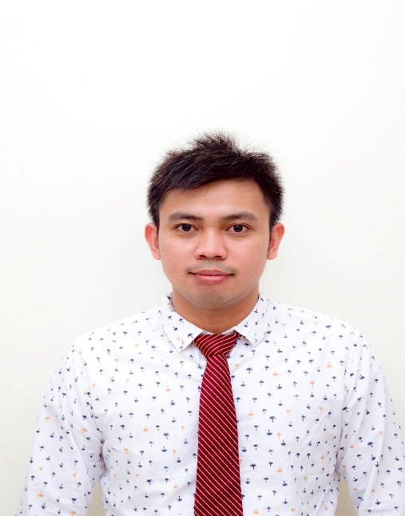

GERALD
GERALD.366024@2freemail.com

OBJECTIVES

To obtain a position that will develop my skills and acquire more contemporary knowledge to be competitively prepared to deal with my respective workplace.

EDUCATIONAL BACKGROUND
Graduate of
2010-2013 BS hotel and restaurant management
Saint Clare College of Caloocan

2008-2009 BS Business Administration
Major in Human resource management
University of Rizal system

2004-2008 High School Diploma
Justice Cecilla Muñoz Palma High School
Molave St. Payatas Quezon City

WORK EXPERIENCE

November 19, 2014-January 08,2017 Service Expert / Restaurant Supervisor
Dairy Queen Restaurant/ Al Safwa Food
Riyadh City, Kingdom of Saudi Arabia
Functions:

- Complete daily inventory count.
- Performs Cashiering, generate bills and answer guest queries about deal offers and service time.
- On the floor supervising peak period, monitor product flow, product quality, food safety practices, customer flow and product quality.
- Answer telephone calls.
- Review and record waste and complete monthly annual maintenance items.
- Train newly hired staff.

April 23, 2013- January 24, 2014 Customer Service assistant/Admin
SM Supermalls,
Mall of Asia complex , Pasay City Philippines

Functions:

- Provides excellent customer service.
- Receives calls from clients /Suppliers/ partners/ and transfer to appropriate department person.
- Takes down messages and relay to appropriate department/ person.
- Assists tenants and customers with their queries/concerns.

TRAININGS

December 20 2014 Dairy Queen Restaurant/ Al Safwa Food
Service crew training
Riyadh City, Kingdom of Saudi Arabia

December 10 2014 Dairy Queen Restaurant/ Al Safwa Food
Chill crew training
Riyadh City, Kingdom of Saudi Arabia

November 30 2014 Dairy Queen Restaurant/ Al Safwa Food
Grill crew training
Riyadh City, Kingdom of Saudi Arabia

September 24-December 02 2012 on the job training-
Traders Hotel Manila
Housekeeping Department
Bakeshop/pastry kitchen
Roxas boulevard,Manila

CERTIFICATION AND SEMINARS

August 02 2010 Trends in the culinary industry
Taal Vista Hotel
Tagaytay City, Philippines

December 09 2010 Actual shipboard Familiarization
M/S Saint Joseph the worker
Pier 2, Manila, Philippines

March 04 2011 Career path development-Sea based Hospitaliy
Industry and Safety of life at sea
ZRC training center Phils, Inc.
Ermita Manila, Philippines

August 05 2011 Comparative study of different hotels
Subic bay Metropolitan authority
Subic bay freeport zone, Philippines

SKILLS

- Computer literate
- Multitasking and Team working skills
- Forward planning, strategy and decision making

