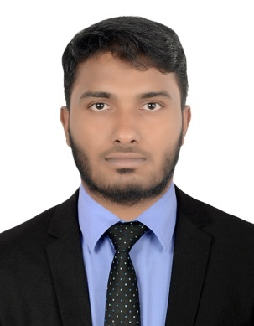

yasar

yasar.366036@2freemail.com

Experience Summary:

- Over 4 years of experience in handling various types of clerical responsibilities and highly confidential tasks with efficiency.
- Maintained accuracy in sorting, filtering, copying, and documenting procedures.
- Efficient punctual and able to multi-task in past-paced environments.
- PC proficient with in-depth knowledge of MS Office.

PROFESSIONAL EXPERIENCE:

Organization : QUICK TYRE AUTO CARE - Dubai.
Designation : General Office Clerk
Duration : 4 Years (18 July 2012 to present)

JOB RESPONSIBILITIES:
- Proficient in maintaining files and records in a safe and confidential manner.
- Skilled in sorting and distributing mail to intended recipients within the organization, and ensuring that outgoing mail is expedited.
- Assisted in typing and distribution of confidential letters for senior members daily.
- Create and maintain office records in both paper and electronic formats.
- Scan incoming mail for recipient information and distribute letters and parcels to intended recipients.
- Operate office equipment such as copiers, scanners and fax machines and ensure that they are maintained efficiently.
- Provide travel and accommodation support to executives by ensuring that details of both are handled in a timely manner.
- Maintain and update office files, inventory, mailing lists, and database systems.
- Collect information needed by the office staff or supervisors.
- Prepares letters and other correspondences.
- Do simple bank transactions and basic book keeping for the company.
- Arrange for the repair or troubleshoot of office equipment.

SKILL SET:

- Operating Systems : MS-Windows XP & Above.
- Computer Literacy : Computer operations, related software and office equipment – MS Office (Word, Excel, Power Point, Outlook), scanners and printers.
- Communication and listening skills.
- Types 45 wpm.
- Knowledge about critical analysis and organizational management.
- Attentive and highly self-motivated professional.
- Ability to follow the directions correctly.

ACADEMIC BACKGROUND:

I have done MBA in major of MASTER OF BUSINESS ADMINISTRATION with 60.1% on June 2016 from ANNAMALAI UNIVERSITY, CHIDAMBARAM state of TAMILNADU, INDIA.

INSTITUTE/UNIVERSITY | DEGREE/EXAMINATION | PERCENTAGE | YEAR
TBMLC  PORAYAR | B.Sc  COMPUTER SCIENCE | 63% | 2012
S.M.H.S  SIRKALI | HSC | 54% | 2009
S.M.H.S  SIRKALI | SSLC | 58% | 2007

CERTICATION COURSES:

- Diploma Hardware and Networking Engineering at Microchip InfoTech with Inplant Training on Manufacturing Operations at LENOVO (INDIA) PVT.Ltd.
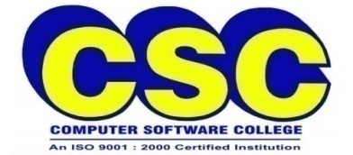
- Diploma in COMPUTER APPLICATION (DCA) at CSC COMPUTER EDUCATION.

STRENGTHS:

- Good communication skills.
- Coordination and organizational abilities.
- Able to do work individually as well as in team.
- Hard-working with lots of patience.
- Adaptability to changing the environment and trends.

DECLARATION:

I hereby declare that the above mentioned particulars are true to the best of my knowledge and belief.

