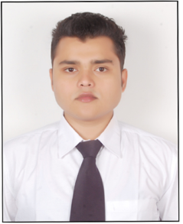
RESUME
PERVEZ

PERVEZ.366072@2freemail.com
Objective:
To Work in a Challenging Situation in Which I Can Proved My Knowledge & Capabilities for the progress.
Educational Qualification:
- Passed High School form C.B.S.E Board New Delhi in 2012.
- Passed Intermediate from C.B.S.E Board New Delhi in 2014.
- B.com final from CCS University Meerut in 2017.
Computer Qualification:

I have completed Three Months computer Basic Course From British Computer Center Shamli
- Operating System Windows
- MS Office MS Word, MS Excel, MS Power point
Others CCC (B grade)
Typing English(50wpm) & Hindi(35 wpm)

HOBBIES:
- TYPING.
- PARTICIPATE IN SPEECH COMPETITION
- TRAVELING
PERSONAL DETAIL:
DATE OF BIRTH 21-06-1996
SEX MALE
RELIGION MUSLIM
Language Hindi, English , Urdu
MARTIAL STATUS UNMARRIED
I Do hereby confirm that all the information in this resume is true and correct to the of my knowledge.

