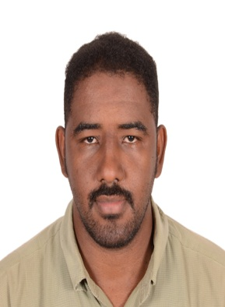
MOHAMMED

MOHAMMED.366083@2freemail.com

Objective:-
Seeking a suitable position within a growth oriented healthcare, where advancement and learning are based on performance and achievement, So I offer all of my efforts, services, and experience, with the capability and knowledge that I have in order to develop myself , achieve the organizational goals , and create acceptable benefits.
SKILLS & ABILITY:-
- Ability to work in team.
- Excellent ability to develop myself.
- Ability to manage a routine lab.
- Fast learning.
- Communication skills.
- Ability to work under high pressure with minimal or no supervision.
- Excellent Knowledge in PC programs.
- Ability to practicing all first aid rules.
- Ethical printability.
- Good presentation skills
EXPERIENCE:-
- Medical Laboratory Technologist - Elubuhayra Hospital Omdurman El Mulazmin 2016-2016
- Medical Laboratory Technologist – Faiha Medical Hospital 2013-2014
- Medical Laboratory Technologist – Elmoutaz Moh Elamin Abdalla Lab 2013–2016
- Medical Laboratory Technologist - Hiraa Specialized Medical Center 2013–2015

WORKSHOPS & CONFERENCES:-
- Health Management Development by Using Quality Concept 2014
- Effective Communication 2014
- Total Quality Implementation Phases 2014
- Health System Leadership Skills and The Role of Quality Managers in Health Care Facility 2014
- Quality Dimensions 2014
- Definition of Health Quality and the ETHICAL Duties of the Doctors and Health Service Provider 2014
- Concept and Basic Approach of Health Care Quality 2014
- Characteristics of the Service Sector and the Difficulties They are Facing 2014
- Quality Cycles and Pioneers 2014
- Definition and Role of Total Quality in Service Sector 2014
- Development and Establishment of Health Care Quality 2014

EDUCATIONAL QUALIFICATOIN:-
- BSc degree in Medical laboratory sciences from Sharq El Niel College, Khartoum, Sudan Awarded in clinical chemistry by November 2011 at school of Medical Laboratory Science
PROFESSIONAL EXPERIENCES:-
- Lab technologist, Equipment management Quality control and maintenance.
- Reporting shortage of materials to the supervisor at the earliest convenience, ordering and approving replenishments when necessary.
- Conducting analysis of specimens to determine the presence of normal and abnormal components on a rotation base in different sections.
- Operating calibrates and maintains lab equipment available in different lab sections
- Evaluating collected laboratory data and prepare reports as per protocol, and providing results to physicians as per defined SOPs.
- Ensuring that SOP (standard operation procedures) and Quality Assurance tests are maintained within all sections.
- Computer maintenance.

REGISTRATION & LICENCES:-
Full registration from Sudanese National Council for Medical & Health Professions as Second Medical Laboratory Specialist in Feb 2013
MOH UAE as Medical Laboratory Technologist (Clinical Biochemistry) in April, 2017
LANGUAGES KNOWN:-
- Arabic fluent read write and speak ( mother language )
- English good read write and speak
PERSONAL DETAILS:-
Date of Birth : 18/09/1988
Marital Status : Single
Nationality : Sudanese
Religion : Islam

