C U R R I C U L A M V I T A E
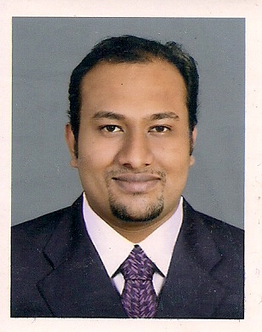  JITTU  JITTU.366113@2freemail.com  Languages known: -  English, Hindi, Malayalam &Tamil | OBJECTIVE  Looking for the position of Finance officer, wherein I can render my service that will be a contributory factor to the success of your organization, and will allow me to enhance my knowledge and skills, that would lead into a fulfilling endeavor.  CAREER ADVANTAGE  Self-motivated. Detailed oriented person and has the ability to persuade others easily and can organize a hard workload. Experienced in setting policies and procedures. A dedicated and career oriented person who values excellence and high standard of work and attitude.  ACADEMIC PROFILE  - CA Inter  IPCE Ist Group – May 2012  IPCE IIndGroup – May 2015  - Bachelor’s Degree in Commerce - 80%  MG University - CMS College Kottayam (2009-2012)  - Higher Secondary, Commerce - 85%  Kerala State - MDSHSS Kottayam (2007 -2009)  - Secondary Exam – CBSE - 70%  Belmont English Medium School (2007)  - Pursuing CA Final  Knowledge Base  - Handful Experience on VAT.  - Calculation, preparation and submission of return.  - Assisting in VAT audit.  - Knowledge of IFRS Standards and Indian AS’s.

WORK HISTORY:

- From December 2015 To April 2017: LTC International Qatar LLC
(LALS Group)
Designation – Senior Accountant / Accounts Supervisor
Job Description.
- Fund Management of the company.
- Managing day to day to activities of the company.
- Finalization of Accounts.
- Preparation of Budgets and Forecasts.
- Supervision of works of colleagues
- Rent booking and reconciliation based on IFRS Standards
- Preparation and filing of tax returns.
- Coordination with head office.
- Preparation of various reports for management decision makings.
- Setting up standard formats and internal control procedures.

- From September 2012 to September 2015: Rangamani& Co., Chartered Accountants,Kerala, India
Designation – Audit Assistant (CA Article)
Job Description.
- Doing Tax Audit of Various Companies, Firms etc.including monthly closure of books by ensuring the compliance of Accounting Standards, Process and Guidelines.
- Internal audit, Bank Audit, VAT Audit, Concurrent Audit. etc.
- Handling assessment related issues under various laws of various clients
- Accounts preparation of various clients
- Preparation and filing of service tax returns,VAT Returns,Income Tax Returns, PF Returns & TDS Returns.

- Accounts head – Part Time – Bharath Time Gallery (2012 - 2015)
Job Description.
- Preparation of final accounts of the firm including their branches and associate firms
- Filing of Sales tax - VAT Returns.
- All Law related compliances.
COMPUTER PROFICIENCY
- Microsoft Dynamics ERP Software
- Tally ERP 9
- Spectrum Taxation Software
- Winman Tax Software
- MS Office

STRENGTHS
- Good communication skills, hardworking& interpersonal skills.
- Meticulous approach in work & able to work under pressure.
- Grabbing the interest of the others easily with my communication skills.
- Highly motivated and competitive in nature with ability to motivate the team.
- Very good Interpersonal relationship.
- Sincerity, fast learner and grasping ability.
- A positive outlook towards life

Deceleration
I Jittu do hereby declare that all the matters mentioned above is true and correct and doesn’t contain any misleading information.

