ARAILYM  ARAILYM.366126@2freemail.com |  |  |  |  |  | 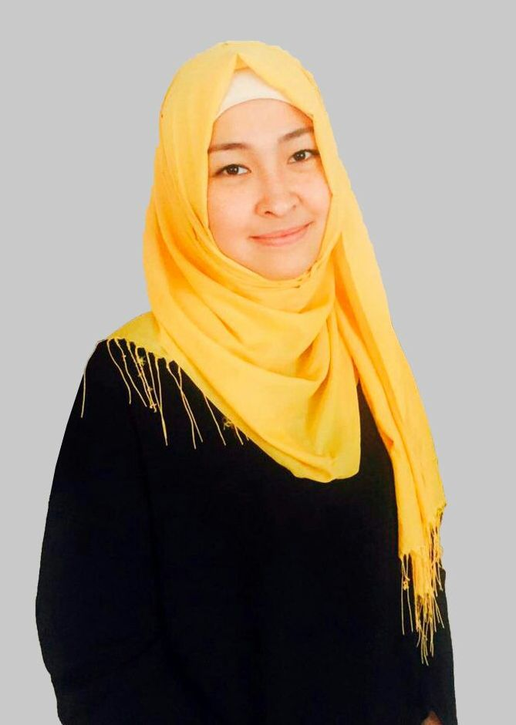
Highlights
• Native Russian & Kazakh |  | • Excellent verbal & nonverbal communication skills
• High-cultural intelligence |  | • Detail oriented, organized, & adaptive
• Love children |  | • Competent in Microsoft Excel, Word, PPP, & Outlook
Education
Sept 2013 – Present | Suleyman Demirel University (SDU)  Faculty of Philology and Educational Sciences |  |  | Kaskelen, Kazakhstan
 | • Major: Two Foreign Languages: English & Spanish  • Degree: Bachelor of Education (B.Ed) |  |  | • GPA: 3.6 / 4.0  • Expected Graduation: June 2017
Work Experience
Apr 2016 – Present  (1 year  1 month) | Intellect Educational Center  English Language Teacher |  | Kaskelen, Kazakhstan
• Effectively teaching 6 multi-level English Second Language children’s groups through learner-centered approach resulting in improvements to their English language communication and comprehension skills
• Maintaining order and discipline in the classroom of students from the ages of 5 to 17 years old
• Modifying assignments and activities to meet the learning needs of individual students
• Effectively communicating in English, Russian and Kazakh with parents, students and the teaching administration to discuss student progress which lead to overall increased parent satisfaction
Apr 2016 – Sept 2016  (6 months) | Administrator / Receptionist
• Managed the day-to-day operations of the Center including keeping track of payments, maintaining accurate student attendance records, answering phone calls, and keeping copiers/faxes in working order
• Effectively scheduled classes to align classes with student’s school times, teacher’s availability and maximize classroom utilization
• Cordially met visitors to capture potential clients, ensure parent satisfaction & uphold company standards
May 2015 – Sept 2015  (5 months) | Leader Taxi / Clever LLP  Call Operator |  |  |  |  |  | Almaty, Kazakhstan
• Managed customer calls effectively and efficiently in a complex, fast-paced and challenging environment
• Addressed and resolved service, pricing, & caller complaints empathetically, professionally and through clear and specific questions
• Worked 12 hour day / night shifts answering over 600 daily taxi calls
Skills & Achievements
Mar 2017 | English Olympiad Certificate for placing in top 20 of National English Olympiad
Sept 2013 – May 2016 | SDU Vision Club: Baganashyl Orphanage Volunteer
 | • Stimulating children’s thinking skills in Baganashyl Orphanage through fun-engaging activities
 | • Organizing 2014 New Year’s Holiday Celebration for school children
 | • Awarded Vision Club Certificate (2016) in recognition of helping orphans better their lives

