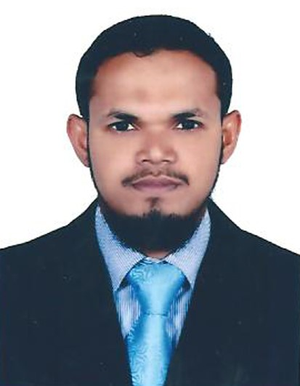
SAHUL

Sahul.366133@2freemail.com

SENIOR SALES EXECUTIVE

PERSONAL PROFILE
- More than 14 years of Professional Experience in retail sales. Specialization in DIAMONDS, PRECIOUS STONES, ARABIC PERFUMES AND LEATHER GOODS.
- Rated as A+ by GOLD PALACE, MANGLORE in reaching the targets and maintaining stocks and debtors within the permissible limits.
- Achieved record sales during the period of recession and maintained sales and collection targets of the company.
- Aimed and contributed to the best to make the regional office into an independent profit center.
- Contributed in making regional office into an independent profit center by opting a rationalized customer group base with high contributed material groups and product lines (product-wise contribution analysis).
- Configuration of Sales supports activities and Interstate stock transport orders.

PROFESSIONAL EXPERIENCE

- Name of company : GOLD PALACE JEWELLERY, MANGALORE, INDIA
- Branch : Ashwini Nagar, Kasaragod, Kerala.
- Position : Senior Sales Executive.
- Duration : 7Th September 2014 to 31st December 2016. (2 years)

- Name of company : LEATHERFIELD.LLC, DUBAI
- Branch : Oasis Center Mall, Sh.Zayed Road.
- Position : Shop Manager
- Duration : 20th May 2012 to 20th May 2014 (2 years).

- Name of company : AL RASASI PERFUMES, DUBAI
- Branch : Dubai Festival City, Arabian Center, Mirdif City Center.
- Position : Sales Executive
- Duration : 12th February 2008 to 31st March 2012 (4 years).

- Name of company: OPERA SHOES, DUBAI
- Branch : Mall of the Emirates
- Position : Sales Man
- Duration : 17th June to 30th December 2007 (6 months)

- Name of company: GOLD PALACE JEWELLERY, MANGALORE, INDIA
- Branch : Aysha Towers, Mangalore.
- Position : Sales Supervisor
- Duration : 02nd February 2002 to 14th June 2007. (5 years & 6 months.

DUTIES AND RESPONSIBILITIES
- Comprehensive knowledge of the methods and techniques of sales and marketing.
- Extensive knowledge of DIAMONDS, GOLD, PLATINUM and GEMSTONES.
- In-depth knowledge of DAHN AL OUD and OUD INCENSE.
- Verifying the sales of each day to increase the sales.
- Ensure the customer satisfaction, and go through new ideas to keep the sales on mark.
- Confirming the received items numbers, weight and condition.
- Stock taking at regular interval given by company.
- Plan and direct staffing, training, and performance evaluations to develop and control sales and service programs.
- Visit franchised dealers to stimulate interest in establishment or expansion of leasing programs. Ensure the customers are attended well and taken care properly to enjoy the shopping.
- Set up and arrange display to attract attention of prospective customers.
- Suggest product improvements to the management.
- Answer telephone and written requests from customers for information about products.
- Marketing of LEATHER GOODS AND LUXURY PRODUCTS with induct knowledge of markets.
- As a Manager with complete responsibility of zonal operations in LEATHERFIELD LLC division marketing - Lead a team of management, accounts, sales, administration.
- Contributed in making regional office into an independent profit center by opting a rationalized customer group base with high contributed material groups and product lines (product-wise contribution analysis)
- Reduced bad debts (from 60 days to 30 days) by strict implementation of clear-cut pricing policies/discount structures/credit policies/exposure limits/risk management guide lines with optimized stock levels (through aging analysis-from 60 days to 15 days sale stock).
- Quality Control and assurance (TSD – in handling customer complaints), Accounts (billing), dispatch department (warehouse and stockyard maintenance) and conversion vendors.
- Key participation -in formulating different pricing conditions, agreements, -in forecasting trends, -in offering different combinations of price and responsiveness to different customers.
EDUCATIONAL QUALIFICATION

- Pre-University degree (PUC) in SCIENCE (Pre-Medical and Engineering) Completed from Mangalore University, Karnataka, India, in the year of 2000/2001.
- SSLC Passed from Karnataka Examination Board in 1998/1999.
- Diploma in Computer Application, M/s Office (Word, Excel, Power Point, tally 6.1), Internet & E-mail in 2001/2002

LANGUAGE SKILL
.
- FLUENT LEVEL : Professional English, Arabic, Hindi, Kannada and Malayalam.
- TO READ and WRITE : Arabic, English, Hindi, Kannada and Malayalam.

TECHNICAL SKILL

- INDO-SOFT JEWEL software operating for jewellery.
- NEPTON’s retail software operating, including barcoding.
- Technically qualified and effective manager, having talent for quickly grasping the focus areas of business – market or client, in identifying client’s exact needs and proposing best solutions and motivating the team with a sense of purpose or objective.
- ERP - Functional consultant, having more than two years of working experience in Tally.
- Gold Quality Check machine operating.

INTERPERSONAL SKILLS
- 14 years of retail sales field experience with 7 years in Dubai.
- Great command and fluency in language.
- Good communication skills, self-motivated, and result-oriented.
- Energetic & enthusiastic individual with a high level of commitment towards work.
- Able to work as a part of a team and to communicate effectively with colleagues and management.
- Confident to handle any situation arising in the course of employment.
- Good communication skills, self-motivated, and result-oriented.
- Developed great soft skills through formal training and past experience.
EXTRA CURRICULUM
- 1ST Prize Winner for QURAN RECITATION @AL-MANAR Centre for Quran Studies, AL QUOZ, UAE IN 2010
- Distinction Certificate in PUBLIC EXAMINATION ON QURANIC STUDIES held by MSM Kerala, INDIA IN 2016.
PERSONAL DETAILS

- Date of Birth : 02nd May 1983
- Religion : Muslim
- Marital status : Married
- Place of Issue : India
- Visa Status : Visit Visa
- Visa expiry : 15/06/2017

DECLERATION

I hereby declare that the above information furnished by me is true and correct to the best of my knowledge.

Yours sincerely,

SAHUL

