Curriculum Vitae
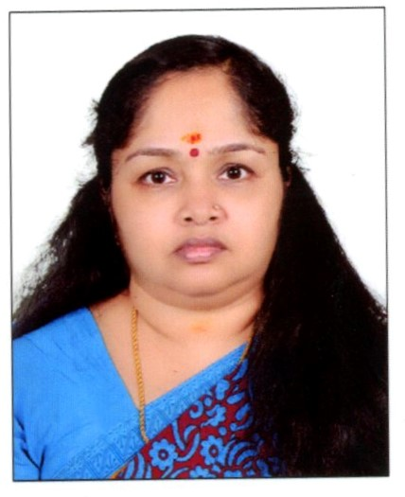

Rakhi

Rakhi.366141@2freemail.com

Career Objective:
To work in a responsible and challenging professional organization where I can use my professional skills, knowledge and my entire personality to prove myself and to prove the best for the organization.

Working Experience:
- Worked as a Malayalam Teacher in S.N.S.S. Vidya Mandir, Nanmanda, Kozhikode, India from 1999 to 2004.
- Worked as a Malayalam Teacher in Sri Sri Ravisankar Vidya Mandir, Kozhikode, India from 2006 to 2008
- Working in a Manpower Supply Company for two years doing all visa process documentation.

Qualification
- Bachelor of Arts degree in Malayalam Language and Literature.
- Bachelor of Education in Malayalam.

Compute Literature
- Microsoft Windows, Microsoft Excel

Declaration:
I do hereby declare that the details furnished above are true and correct to the best of my knowledge and belief.

