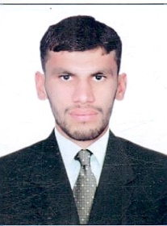
Curriculum vitae
FAIZ
FAIZ.366161@2freemail.com
PROFILE
A suitable position with an organization where I can utilize the best of my skill and abilities that fit to my education, skill and experience a place where an encourage and permitted to be an active participants as well vital contribute on development of the company.
PERSONEL SKILLS
- Very energetic oriented
- Physical mobility and stamina to do all tasks
- Extremely working self motivated and able to work independently

ACADEMIC QUALIFICATIONS
- Metric. (Science). Board (BISE Mardan), Marks (665/1050).
- F.A (g science). Board (BISE Mardan), Marks (535/1050).
- B.A (political science, islamic study) Abdul Wali Khan University Mardan. Mark (252/550).
- DIPLOMA INFORMATION OF TECHNOLOGY (ONE YEAR) Board (BTE Peshawar), Marks 1016/1400

PERSONAL INFORMATION
Date of birth : 10/03/1995
Nationality : Pakistani
Gender : Male
Marital status : UNMarried
Languages Known : Urdu, Pashto, and English
Religion : Islam

CURRENT W0RK
Transguard group of company is a porter position .

COMPUTER SKILL
(ms-office)(window xp)(window 7)(photoshop)(coreldrew)(networking)(webdesigning)(grapic designing)(computer hardwar) etc.

CONCLUSION AND DECLARATION
I hereby declare that the above information are true and correct according to the best of my knowledge and my Experience. If selected I assure I would perform to the best of my abilities, early awaiting a Positive response.

