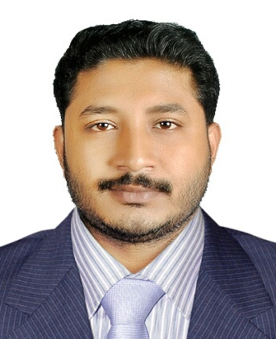
Reignomea
Reignomea.366165@2freemail.com

Objective
To devote my knowledge, experience, skills, and energy to the treatment and well-being of animals and to work for an institution reputed for its excellence in fostering animal care.

Experience
Veterinarian 2015 (1.5 years)
1. Doctor at Sahrdaya Veterinary Clinic, Kollam, Kerala, India.
Veterinarian 2016-2017(cntd…)
1. Doctor at Naïf, Kuwait.

Education
Kerala Veterinary and Animal Sciences University, Pookode, Kerala, India.
Bachelor of Veterinary Science and Animal Husbandry (BVSc and AH)
Period: 2008-2015. Year of pass. 2015
Government Higher Secondary School, Anchalummoode, Kollam, Kerala, India.
Higher Secondary Examination (ClassXII)
Period: 2004 – 2006 Year of pass. 2006
Thangal Kunju Musaliar Centenary Public School. T.K.M College Campus Kollam
Central Board of Secondary Education – Secondary School Examination
Period: 2003 – 2004. Year of pass. 2004.

Personal information
- Civil Status: Single,
- Date of Birth: 13.01.1988
- Interests: Pets, Reading, painting, sports

Passport Details
Sex: Male
Caste & religion: Islam, Muslim.
Date of Birth: 13.01.1988

Place of Birth: Kollam, Kerala, India

Nationality: Indian.

Place of Issue: Trivandrum

Date of Issue: 02.07.2015

