TUHIN

TUHIN.366173@2freemail.com
MANAGEMENT PROFESSIONAL

Profile Summary | Area of Expertise
- A specialist with extensive experience in the entire gamut of Supply Chain Operations with domain expertise in Procurement, Material Management and Global Sourcing  - Extensive experience in working with industries like Manufacturing, IT, BPO, Metals, Telecom, Sea Logistics, Retail  - Currently managing procurement of total US $ 293 million in a year  - Effective in developing overarching global sourcing strategy with focus on transforming the procurement function into a value creation group by working in collaboration with stakeholders, cross function partners, and strategic supplier alliances to generate year-over-year productivity  - Demonstrated excellence in undertaking operations related to logistics, projects stores and inventory control, codification of materials, issue & receiving of materials, scrap disposal, wastage control and packaging systems  - Extensive experience in defining and managing the implementation of purchasing strategies with effective cost reduction benefits; proficient in developing request for purchase quotes; reviewing procurement volumes by product class / customization, thereby identifying areas for rate / frame contracts and finalization  - Skilled in spearheading stock of material without variance by conducting stock verification; monitoring hygiene and taking safety measures  - A determined individual with strong interpersonal and negotiation skills establishing and maintaining best purchasing practices within a changing business environment; catered to challenging situations and delivered effective result | Global Sourcing  Material Management  Global Procurement Strategy  Contract Management  Business Continuity Planning  Vendor & Manpower Management  E-Sourcing  Inventory Planning  Team Building & Leadership
Education
2000 MBA from CSM Institute of Graduate Studies, Canada
1992 Graduate Diploma in Materials Management from Indian Institute of Materials Management, Calcutta
1994 Diploma in Computer Science from IGCS Mumbai
1991 B.Com. from Calcutta University
Career Timeline
Citigroup Global Services Ltd. (TCS-eServe), Mumbai as Senior Manager – (Technology Procurement)
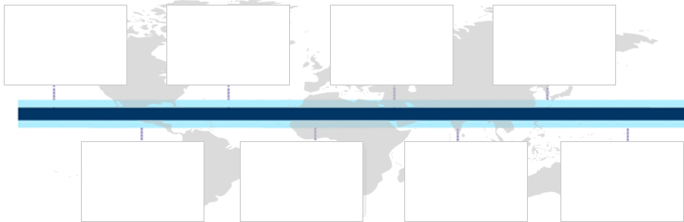
May04 - Sep08

Feb04 -Apr04

May02 -Feb04

Aug01 -May02

Jul98 - Aug01

Sep96 - Dec97

Jun94 - Aug96

Aditya Birla Management Corporation, Mumbai as Deputy General Manager (Commercial)

Al Watania Plastics Riyadh (Saudi Arabia)
as Stores In-charge
Kilburn Engineering Ltd. Mumbai as Officers (Stores)

Allied Digital Services Pvt. Ltd., Mumbai as Manager (Purchase
& Stores)

Media Lab Asia Mumbai as Manager (Procurement)
GMS Technologies Ltd., Mumbai as Asst. General Manager (Projects)
Tata Internet Services
Ltd. (Tata Indicom),
Mumbai as Executive (Commercial)

Sep08 -Present

Notable Accomplishments Across The Career
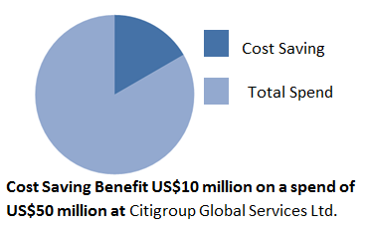
- Managed total procurement over US$ 230 million in a year which includes Petro Products, MRO Items, Courier, It products, Ocean Freight and so on for Aditya Birla Group
- Achieved 75% reduction on technology requirement and cost saving benefits of US$10 million on spend of US$50 million by developing closer supplier relationships, negotiation, re-engineering of business process, performance specifications for Citigroup
- Established the Purchasing Department structure and effective in recruiting a team to provide a comprehensive procurement service within BPO Company and Corporate Company
- Introduced an on-line computerized purchasing database to maximize benefits from centrally negotiated contracts, improve the communication of product / service agreements and enhance the Divisional invoice matching process
- Reviewed internal supply chain processes, defined & implemented Oracle P2P process Module for the use of the Purchasing Dept.
- Minimized audit finding and enhance RCSA ratings in ARR, PRR; updated all tech. procurement policies, guidelines intern with Citigroup / CGSL policies, Closing AMC /FMS Agreements which resulted into savings of 35% -40% at Citigroup Global Services
- Led company-wide global sourcing initiatives in spend management for both manufacturing and indirect spend and reduce costs by over US$ 80 million in last 7 years in Aditya Birla Group
- Delivered 12 large capital expenditure contracts / projects 50% faster, saving additional 19.3% in capital expenditure contracts and improving gross margins & revenue
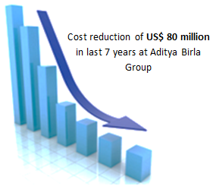
- Administered the cost, quality, delivery and project launch of a material budget of around US$ 205 million; worked as part of the Task Force Committee (management team) undertaking Businesses/ Units
- Secured around US$ 3.5 million material savings on IT products

Memberships
- Member of:
- Indian Institute of Materials Management
- Institute of General Health and Hygiene

Work Experience
Sep’08 – Present Aditya Birla Management Corporation Pvt. Ltd., Mumbai as Deputy General Manager (Commercial)– Corporate Management Services Division
Key Result Areas:
- Spearheading the entire gamut of process operations and managing total procurement over US$ 230 million in a year
- Undertaking RA (Reverse Auction) in group wide ocean freight, raw materials, transportation and so on; managing E–buying, global sourcing, vendor development, cost reduction related operations, working knowledge of the e-Sourcing tools system for contracts and sourcing events
- Conducting:
- Aditya Birla Group wide MOU’s in Petro Products (like Furnace Oil, LDO, HSD, HFHSD, Bunker Oil, Lubes)
- Group wide MRO Items MOU’s (like Bearings, Motors, Cables, Electrodes, Switchgears, Valves, Paints)
- Group wide IT Products MOU’s (like Laptop and Desktop, Routers and Switches, Printers and Scanners, Software etc.)
- Group-wide MOU’s for Couriers / Relocation services
- Performing as In-charge of consulting entire procurement departments of the group companies as a profit centre to enhance the profitability of the organization
- Driving the procurement function of India businesses, provided senior level support to category & operation team in global strategy implementation, sourcing, negotiation, discussion and recommendations; partnered with regional stakeholders for key vendor review (strategic & operational)

May’04 – Sep’08 Citigroup Global Services Ltd.(Currently TCS eServe), Mumbai as Senior Manager - TPU (Technology Procurement Unit)
Key Result Areas:
- Acted as In-charge of Centralized Technology Procurement. Managed more than 15 resources
- Managed procured Software Inventory Database and worked closely with Tech projects, IT Services & GCC Tech teams for overall Software Inventory, Importing IT Material in STPI/NSTPI/SEZ
- Imparted assistance to the tech team to deliver the targets especially in support areas; ensured on time impartment of mandatory and functional training; motivated and empowered unit staff to increase productivity
- Evaluated vendors bi-annually and mentioned corrective action in each case; worked with VRM to do vendor assessment on a half yearly basis for all on-site contractual work
- Undertook Background Checks of Vendor staff, Tools used: P2P (Oracle)

Previous Experience (Jun’94- Apr’04)
Media Lab Asia: Managed 5 resources, saved 30% on spend of US$10 million on IT products.
Tata Internet: Provide MIS reports, vendor development, saved 45% on spend of US$30 million on IT products.
Allied Digital: Managed 8 resources, achieved savings 12% on spend of US$ 15 million on IT products.
Al Watania Plastics: Managed 5 different category stores & warehouse (area 50 Lacs sqft) cutting down the inventory cost by 30%.
Kilburn Engineering: Managed engineering & project stores/warehouse and cutting down the inventory cost by 20% in a year.

Soft Skills
IT Skills
Proficient in MS Office, Internet & E-mail Application

Trainings & Seminars
- Attended trainings, workshops and seminars of: Materials Management, General Management and Self-Development

Extracurricular Activities
- Represented Regional Level in Athletics
- Received awards from Government of Gujarat
- won many awards in Tacks & Fields (Zonal, District & College Level)

