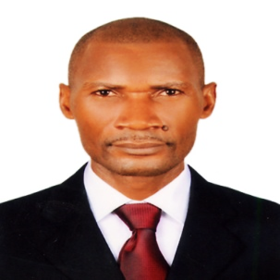

**OBJECTIVE:**

Finding a position as a security guard officer or a closely related position within a dynamic organization where I will be allowed to fully use all my skills and get rewarded.

Responsible | Honest | Trust worthy | fast learner | Takes initiative | Good communication

**PERSONAL INFORMATION:**

DATE OF BIRTH : 31th Dec 1973

MARITAL STATUS : Married

NATIONALITY : Cameroon

VISA STATUS : Visit Visa (03 month) Entry Date 24-02-2017

**WORKING EXPERIENCE**

***2015 2016: Sales Executive- Hope and Faith shop, Cameroon***

*Responsibilities:*

* Welcomes customers by greeting them; offering them assistance.
* Directs customers by escorting them to racks and counters; suggesting items.
* Advises customers by providing information on products.
* Helps customer make selections by building customer confidence; offering suggestions and opinions.
* Documents sale by creating or updating customer profile records.
* Processes payments by totaling purchases; processing checks, cash, and store or other credit cards.

***2011 - 2015: Security Officer- T.C Security Service, Cameroon***

*Responsibilities:*

* Patrol industrial and commercial premises to prevent and detect signs of intrusion and ensure security of doors, windows and gates.
* Answer alarms and investigates disturbances.
* Monitor and authorize entrance and departure of employees, visitor and other persons to guard against theft and maintain security of premises.
* Warm persons of rules infractions or violation and apprehend or evict violators from premises, using force when is necessary.
* Write report of daily activities and irregularities, such as equipment or property damage, theft, presence of unauthorized persons or unusual occurrences.

***2007 - 2010: Real Estate Agent- S.A.D, Cameroon***

*Responsibilities:*

* Worked closely with developers and business owners to facilitate commercial sales.
* Responsible for developing and executing Internet marketing programs for each listing.
* Responsible to finding new residential sales leads and closing on sales.
* Assisted in setting up booths at trade shows and career fairs.
* Part of a team that developed and maintained contacts with the local business community.
* Extremely refined communication and presentation skills
* Able to work with a team or alone

**EDUCATION QUALIFICATION:**

2001 - 2003; BA in Law (in progress), University of Douala, Cameroon

2000 – 2001; High School Diploma in Law

**COMPUTER SKILLS:**

* Microsoft Office (MS Word, Excel), Web, E-mailing, and Browsing.