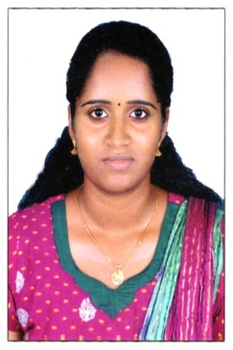
CURRICULUM VITAE

KEERTHI
KEERTHI.366192@2freemail.com

CAREER OBJECTIVE
To practice as a successful dental surgeon in a dynamic environment that allows utilization of my inherent strength, acquired skills and offers scope for learning and growth.
CLINICAL EXPERIENCE
- 3 years and 3months of clinical practice in Olavakkode Family Dental Clinic, Palakkad Kerala India from 1ST October 2012 to 30TH January 2016
- One year of Rotatory Internship at JKK Nattaraja Dental College and Hospital Chennai India from 22ND September 2011 to 21ST September 2012
- Worked in Dental Square, Mulanthuruthy, Ernakulam, India from 01 February 2016 to 19 December 2016
- Registered as a Dentist in the year 2013, from Kerala Dental Council, Trivandrum India.

SPECIALIZED SKILLS
- Excellent diagnostic skills using clinical knowledge and x-rays
- Excelled in extractions, restorations, anterior and posterior root canal treatments, partial and complete dentures, fixed and removable appliance therapy, scaling.
- Participated in many dental checkup and treatment camps
EDUCATIONAL PROFILE
COURSE | BOARD/UNIVERSITY | NAME OF THE COLLEGE/ SCHOOL | YEAR
BDS | Tamil Nadu Dr MGR Medical University, Chennai, India. | JKK Nattraja Dental College and Hospital, Chennai, India | 2012
AISSCE | CBSE | Mahatma Gandhi Public School Thiruvamkulam, Ernakulam, Kerala India | 2007
AISSE | CBSE | Mahatma Gandhi Public School Thiruvamkulam Ernakulam, Kerala, India | 2005

SEMINARS ATTENDED
- MIS COURSE ATTENDED IN 2012 DEPT OF PROSTHODONTICS, J.K.K.NATTARAJA DENTAL COLLEGE & HOSPITAL KOMARAPALAYAM CHENNAI INDIA.
- CERTIFICATE OF ATTENDANCE OF SCIENTIFIC SYMPOUSIM ON “ORAL SYSTEMIC HEALTH” CONDUCTED BY COLGATE PALMOLIVE INDIA LTD. IN ASSOCIATION WITH J.K.K. NATTARAJA DENTAL COLLEGE CHENNAI INDIA.
- ATTENDED DENTAL EDUCATION PROGRAMMES CONDUCTED BY INDIAN DENTAL ASSOCIATION PALAKKAD DISTRICT BRANCH,KERALA INDIA

LANGUAGE SKILLS
- Malayalam
- English
- Hindi
- Tamil

Declaration:
I hereby declare that the information and facts stated above are true and correct to the best of my knowledge.

