curriculum vitae | 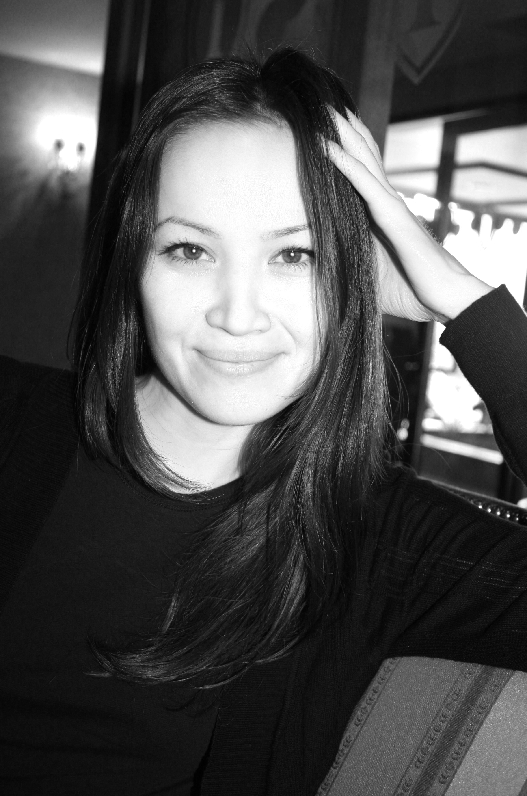
Olga
Olga.366266@2freemail.com
Architect

Profile
After obtaining my diploma in Architecture, Civil and Industrial Construction at the Caspian State University of Technologies and Engineering in 2002, I worked for several (international) architectural and engineering firms. During my career I have been involved in and have contributed to several projects in Kazakhstan, such as a shipbuilding and ship repair yard in Kuryk, the Cargo Transportation Route (CaTRo) project in the Caspian Sea, include a 70 km access channel, port with 1300-metre-long quay and 120 km road, for the support of transhipment of large units (up to 1800 tons), and a multifunctional residential complex with underground car parking in Almaty.

With over 7 years of professional experience in architectural and civil engineering, I developed myself as an all-round Architect and Project Engineer, capable of overseeing different fields of expertise, combining input from different disciplines into integral design solutions and manage project deliverables according to the time schedule.

Specialties
Architecture, Building Engineering, Civil Engineering, Infrastructure, Project Coordination, Project Organization

Career
2009-2016 | Position held: Freelancer. Public Relations / Event / Copyriting / Advertising, Republic of Kazakhstan
2014-2015 | Position held: Project Engineer. Witteveen+Bos Caspian LLP, Republic of Kazakhstan
2013-2014 | Position held: Project Engineer. RDC "Prognoz", Republic of Kazakhstan
2013 | Position held: Project Engineer. Witteveen+Bos Caspian LLP, Republic of Kazakhstan
2010-2011 | Position held: Press Secretary. KazRosGas LLP, Republic of Kazakhstan
2010 | Position held: PR Manager. Your Vision, Blog-platform LLP, Republic of Kazakhstan
2009-2010 | Position held: PR Director. Nursai Show Service, production, Republic of Kazakhstan
2008-2009 | Position held: PR Director. Kaz Navigation Invention LLP, Republic of Kazakhstan
2007-2008 | Position held: Architect. Planshet, LLP, Republic of Kazakhstan
2005-2007 | Position held: Project Engineer. SPCE Aktaugradkadastr, Republic of Kazakhstan
2000-2005 | Position held: Radio host, producer, author of programs, sound designer. RIF, Radio (Europa+ /Russian Radio), Republic of Kazakhstan
1997-2000 | Position held: Radio host, producer, author of programs, sound designer. Tandem, Radio, Republic of Kazakhstan

Experience / Projects
2015 | Shipbuilding & Ship Repair Yard in Kuryk, Republic of Kazakhstan (client: Agip Caspian Sea B.V.). The project involves the design and engineering of a new shipyard suitable to satisfy the forecasted potential market in the Caspian Sea for shipbuilding and ship repair and maintenance activities.  As Project Engineer Assistant Engineering Manager involved in the design coordination of the Port Master Planning, breakwater and design of dredging works, as well as the coordination of the geotechnical survey scope and collection of the input for the Environmental, Social and Health Impact Assessment (ESHIA).
2013-2015 | Cargo Transportation Route (CaTRo), Caspian Sea, Republic of Kazakhstan (client: TengizChevrOil / TenizService LLP).  As Project Engineer involved in the preparations of Concept Design, Detailed Design (DD) and Technical Project Documentation (TPD) for the Cargo Transportation Route (CaTRo) include 70 km access channel, port with 1300-metre-long quay and 120 km haul road, for the support of transhipment of large units (up to 1800 tons) for TengizChevrOil (TCO) Future Generation Project (FGP).
2014 | Repair shop for oilfield equipment, Republic of Kazakhstan (client: Buzachi Operating Ltd). As Project Engineer involved in the preparation of design documentation of a repair shop, include the preparations of calculations, explanatory notes and other technical documentation.
2013-2014 | New build Recycling Facility for the collection and recycling of paper and oil products, Aktau, Republic of Kazakhstan.  As Project Engineer involved in the Detailed Design preparation, include the preparations of calculations, explanatory notes and other technical documentation for administration buildings, foundations of water and gasoline tanks and fences.
2008 | Residential complex ‘Gauhartas’ include underground car parking and utility / service facilities in Almaty, Republic of Kazakhstan (client: MAG group).  As architect involved with the preparation of Detailed Design documentation, include necessary design calculations, explanatory notes and other technical documentation.
2008 | New build five-storey building in Almaty, Republic of Kazakhstan (client: classified).
2007 | Multifunctional residential complex ‘Zhastar’ with underground car parking in Almaty, Republic of Kazakhstan (client: MAG group).  As architect involved with the preparation of Detailed Design documentation, include necessary design calculations, explanatory notes and other technical documentation.
2007 | Trade Center with offices, Almaty, Republic of Kazakhstan.  Preparation of Detailed Design documentation, include design calculations, explanatory notes and other technical documentation.
2007 | Renovation Aktau Hotel, Aktau, Republic of Kazakhstan.  As Project Engineer involved in the Detailed Design preparation, include the preparations of calculations, explanatory notes and other technical documentation.
2006 | Hospital, Aktau, Republic of Kazakhstan.  Preparation of Detailed Design, include design calculations.
2005-2006 | Public School, Aktau, Republic of Kazakhstan.  Preparation of Detailed Design, include design calculations.

Education
1998-2002 | Caspian State University of Technologies and Engineering (named after S. Yessenov), Aktau, Republic of Kazakhstan. Degree in Architecture, Civil and Industrial Construction.

Languages
 | speaking | reading | writing
Russian (mother tongue) | good | good | good
English | good | good | good

Skills
Autodesk AutoCAD, Microsoft Office (Word, Excel, Powerpoint), Adobe Photoshop, Adobe Audition (Cool Edit Pro).

Other Experience / Projects
2015-2016 | Bathroom and sanitary hardware store Vodolei, Aktau and Astana, Republic of Kazakhstan. As freelancer responsible for the design and development of branding manual, advertisement and promotion campaigns (advertisement, banners, brochures, billboards, etc.), interaction with designers and suppliers, media planning and related PR activities.  Also involved in the opening of branded stores in Aktau and Astana.
2013 | Event ‘Builder's Day’, include participation of the Prime Minister of Kazakhstan, Astana, Republic of Kazakhstan.  Involved in organization of the event, screenwriting and preparation of scripts for film presentations.
2011 | Organisation of charity event ‘From a Pure Heart’ as part of ‘Children's Day’ in Almaty, Republic of Kazakhstan, include the organization of press conferences in collaboration with rehabilitation center for children and adolescents with disabilities ‘Meirym’ and ice show ‘Ice and Fire’, performed by Russian Olympic champions and artists.  Partners event: KazRosGas, Gazprom Germania GmbH, TAK Group, LPG Distribution, KazTurboRemont, Fitnation.
2010 | The jubilee forum of «Bolashak» International scholarship with participation Nursultan Nazarbayev, the President of the Republic of Kazakhstan.  Screenwriter of event
2010 | Charity event ‘Equal access - equal opportunities’, Almaty, Republic of Kazakhstan.  As Manager Public Relations involved in the organization of the event include program of the show and press releases.
2009 | Event ‘Happy Chance’ for City Plus stores in Almaty, Republic of Kazakhstan.  Organization and script of the event.
2009 | Live music event ‘York Fest’, Almaty, Republic of Kazakhstan.  Organization of the event and press conferences.

Other Skills
Writing: Preparation of press releases, speeches, articles, advertising texts, scripts for programs (TV and radio) and scripts for events.
Public relations and event management: Organization of festivals, concerts, sport and entertainment shows, charity events, corporate events and press conferences. Presentations of blog platform for advertising agencies and media, conducting trainings, participation in conferences
Tv & radio: Coordination and preparation of presentation films, TV programs and scripts for programs.
Advertising: Development and design of advertisement and promotion campaigns (brochures, banners, billboards, leaflets, branding manual)

