Jennifer 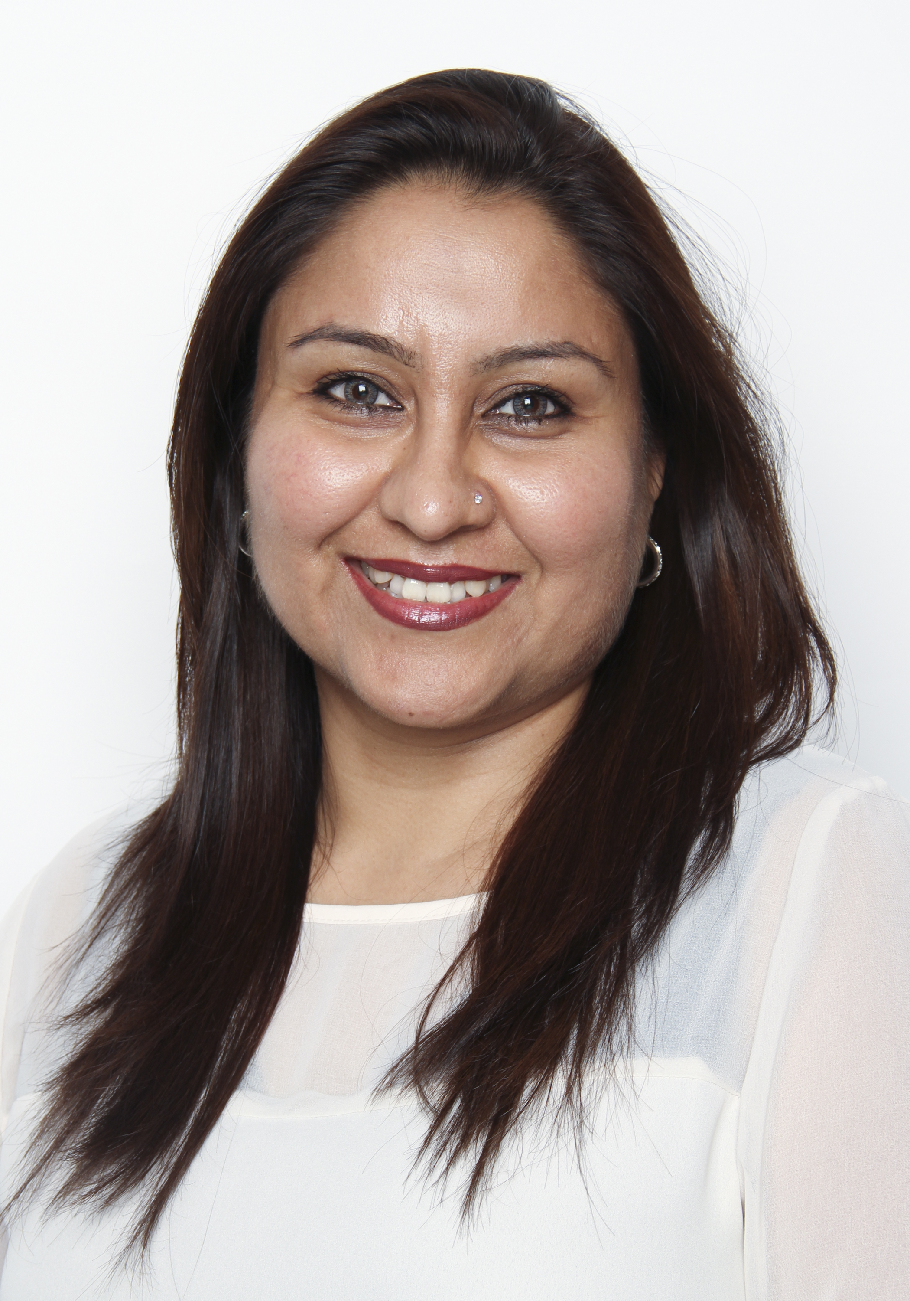
Email id: Jennifer.366287@2freemail.com CAREER OBJECTIVE
To work for an organization that hones my passion for education and churns is productively to fit their school philosophy, to find a synergistic fit with an organization that provides a lot of training and learning opportunity along with a scope for professional development.
PROFILE
Self-directed, enthusiastic educator with a passionate commitment to student development and the learning experience, ensuring diverse communication skills that represents the basis of humanity is inculcated, while always emphasizing on the relevance of class material to the world beyond the classroom.
Active team member who effectively collaborates and makes positive impact / change with all levels of staff members and establishes quality relationships with students, parents that builds a holistic school environment

EDUCATIONAL QUALIFICATIONS

1998 | B.A. & B.Ed. from Regional Institute of Education, Bhubaneshwar. | Degree in English, Geography and History with Honours and a Degree in Education with Distinction
2001/02 | Diploma in Computers | Exposure to E-Commerce Related Technology (1-2-3)
2007 | TESOL, Dubai | Master Teacher Certificate
2011 | CICT, Dubai | Cambridge International Certificate for Teachers with Distinction
2015-2017 | M.Ed. IGNOU | Master in Education through distance Education  Awaiting results.

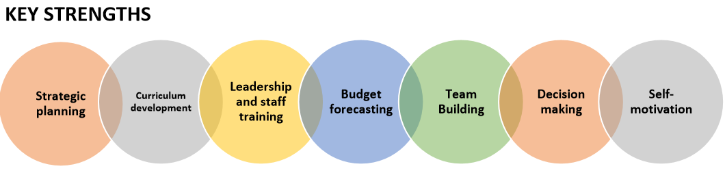

Head of Secondary School: June 2016

My Role as Head of Secondary School involves:
Curriculum Design & Innovation including National Agenda.
Assessment, Reporting & Recording, Provide academic orientation for all students especially KS4
Monitoring, Evaluation & Review of all aspects of Secondary school, Target Setting & Performance Data
CPD – (Continuous Professional Development) trainer for Secondary School – crucial to school development.

* To assist the Principal in shaping a vision and direction for the school, setting out very high expectations and with a clear focus on pupil achievement, standards and quality of teaching.
* To play a significant role in setting aims and objectives for the school and in formulating the School Improvement Plan along with the Principal and other senior staff.
* To inspire, motivate and influence staff and pupils, taking a leading role in maintaining the highest standards of learning and teaching and behaviour management.
* To provide an excellent role model for all members of staff and for pupils in all aspects of school life and provide academic orientation for all new students.
* To make a significant contribution to the schools continuing professional development programme, delivering CPD and working with individuals and teams in a variety of professional development activities.
* To maintain an informed view of standards and of the quality of learning, to inform students and teaching across the school by monitoring pupils’ work and teachers’ planning and teaching.
* To provide coaching guidance and support to HOD’s, HOY’s Subject Leaders and other staff in order to improve the quality of learning and teaching.
* To assist the Principal in all aspects of the day-to day administration and organisation of the school, as agreed with the Principal, including taking responsibility for agreed areas, e.g. Timetable and Reporting to parents etc.
* To participate in recruitment and selection, as agreed with the Principal.
* To deputise for the Principal in the event of absence or unavailability, by carrying out leadership and management tasks in accordance with school policy and practice.

September 2012 till June 2016: Head of Middle School GEMS Winchester School – Dubai
Curriculum Design & Innovation including National Agenda.
Assessment, Reporting & Recording, Provide academic orientation for all students especially KS4
Monitoring, Evaluation & Review of all aspects of Secondary school, Target Setting & Performance Data
CPD – (Continuous Professional Development) trainer for Secondary School – crucial to school development.

- Monitoring and Mentoring students’ progress.
- Develop and maintain a cultural and Educational programme that are in record with the school’s mission, promote learning, build a sense of community and meet academic, aesthetic , affective needs of young adolescents.
- Conducted CIE and CAT4, Progress tests examinations.
- Brain child behind the WIFF – Winchester’s International Film Festival for 3 consecutive years
- Acquired for the School Cambridge Accreditation.
- Preparing an Action Plan for the school, to work on intervention strategies to raise attainment and progress.
- Identifying Students with SEN / ELL and G&T, and helping them cope and improve.
- Family Learning Newsletters to support Parents
- Aim High Programmes – developed to keep students engaged and challenged during the summer holidays
- “Go to work with your Parent” programme.
- Student Leader profiles and Student led conference was initiated for self-awareness and responsibility for one’s own learning.
- Organised a trip to the UK with 30 students for an English Language Course for Girls to Brighton and a Football plus course for Boys.

Sept. 2008 – till June 2012 Head of Key stage 3 &
Humanities Teacher at Winchester - Jebel Ali
- Overlooking of the KS3 - Monitoring and Mentoring Students progress
- Raise standards of the KS3 in Academics, Curriculum and Discipline.
- To assist the Head of Secondary, in all aspects of Key stage 3 improvements, including taking full responsibility of the Key stage.
- Ensure the delivery of outstanding standards of Academic performance and care over my Key stage as well as in my classes.
- Smooth Functioning of Teaching and learning within KS3.
- Part of the thriving, dynamic leadership team focusing on whole school development.
- Mentoring teachers and raising working standards and professionalism.
- Yr. 12 Geography teacher, Yr. 10 and 11 Geography teacher, Yr. 10 Global Perspectives teacher, Yr. 10 and 11 Environmental Management teacher.
- Co-Founder of SMILE – Share More, Improve Lives, Enrich (A non Profit School organization with Students)
- Peer Mentoring / Foster Youth started within the Key Stage 3

Head of year 11.
The Winchester School, Year 2008 till 2011
Gardens, Jebel Ali – Dubai,
UAE.
Head of Yr. 11 and 10,Yr. 11 Environment Management teacher,Yr.10 & 11 Geography teacher, Yr. 9, 8 and 7 Social Studies teacher.
Coordinating with different members of the faculty and working together for the benefit of the school.
As the Head of Year 11, my duties are to guide the form tutors to nurture and impart foster care to the students. I am extremely approachable and yet stand firm in areas of discipline and code of Conduct.
Instrumental in organizing field trips. Eg. All students were given the opportunity to visit the Sharjah Wildlife National Museum, which was both educational and exciting.
Organised Educational trips to the Masai Mara in Kenya and Nepal for Key stage 3 and 4 students for subjects such as Sociology and Geography and EVM. It was very successful.
Influential in guiding Yr. 11 students with Careers.
Actively involved with the Curriculum Enrichment programme that has been part of the curriculum for Yr. 10 students. We divided the academic working year into 3 segments and conducted various interesting activities. In the first segment we learnt photography in the second we learnt cooking and in the third we are learning dancing.
Spearheaded an NGO with my Geography and EVM Key Stage 4 students called SWAC (Superheroes without a Cape) for raising funds for various charities.
Worked towards establishing the Duke of Edinburgh Awards at The Winchester.

April 2002 – June 2007 Senior Social Studies Teacher & Class Teacher for Grade 9 & 10. Dubai Modern High School – Dubai, UAE

Area of Responsibility included besides Class Teachers duties:

Differentiated Instruction, Cooperative learning, Student motivation, Interactive learning with ICT, Classroom management, Students centered learning, Multicultural Awareness
Student assignment, Whole group learning, providing advice and assistance to students on various studying techniques that benefited students to achieve excellent results.
Counseling students and handling grievances of parents and students.
Employing creative and innovative educational techniques to drive growth.
It enabled students to experiment and broaden their horizon.
Monitoring and liaising with the parents on a regular basis for the benefit of the students in progressing towards better result in the board examinations.
Students, Parents and the Institution were well pleased with the creative aspects and innovative and unique methods of Teaching.
Crucial member for the afternoon Self Improvement Program. Coached students in basket Ball, Table Tennis, Throw Ball
Conducted Personality development Program for the students of the Middle School
Organized Educational Overseas trips to Sri Lanka for Geography students Year 10.
October 1998 till March 2002 Social Studies Teacher & Class Teacher
for Grades 6 & 7 Loreto Convent Asansol – India
Areas of responsibility same as above
******************************************************************************************
PERSONAL ACCOMPLISHMENTS

Passed the 36th Annual All India UN Information Test conducted all over India.
Organized a trip to Sri Lanka for the grade 10 students, 32 in nos.
Conducted an Etiquette and Personality Development programme for the children, worked closely with Patricia O’Sullivan the Managing Director, from the Washington DC.
Organized Team Building programme conducted by Terry Kinane an associate with Patricia O’ Sullivan from the Protocol school of Washington.
Conducted Power point presentations for the Geography workshops and for the Staff meetings held by the Principal.
Conducted a team-building programme for the staff conducted by Terry Kinane associate of Patricia O’ Sullivan.
Represented School at the National Basket Ball Championships and college against Norwegian Visiting College at student exchange program.
Represented and were champions in Throw Ball for all 4 years of college and played competitively at school level.
Was in charge of Basket Ball and Table Tennis for the Afternoon Self Improvement Program at Dubai Modern High School during my employment there.
Animator for the Duke of Edinburgh Awards for Girls at The Dubai Modern High School.

Skills

Computer literate with full working knowledge in Windows & Microsoft office.
Quick to learn and persistent in carrying out a task.
With my never say die attitude and high expectations from myself plus my working environment to promote and raise the standard of a professional work atmosphere and to enhance quality education to build a dynamic school environment.
Throughout my work experience, I have successfully achieved all targets set by management. I can confidently assure you of my strong interpersonal skills, effective communication at all levels while exercising tact and diplomacy, capacity to work on my own initiative, sound performance under pressure, productive time management, and quick learning ability while demonstrating a high level of team contribution. I am a very professional individual, exceptionally well groomed and English is my first language. I am meticulous in my approach to work, accurate and detail orientated as well as having a very good rapport with members of my team and clients both in person and over the telephone.

