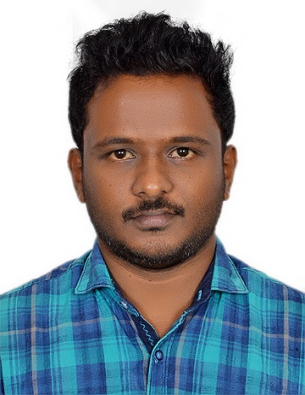

Krishna
Krishna.366320@2freemail.com

Summary: BE Mechanical Engineer with 2 Years of Work Experience.

Experience  Site Engineer Dec 2015 – Feb 2017  Brothers Engineering & Erectors Ltd  India  - Site Engineer for fabrication and fire fighting pipeline erection fitting.  - Project of fire fighting system pipe line retro fitting work in Udupi Power Corporation Ltd, Karnataka.  - Supervising and overseeing the direction of the project, ensuring that the client’s specifications and requirements are met, reviewing progress and liaising with quantity surveyors to monitor costs.  - Making safety inspections and ensuring construction and site safety  - Providing training on safety measures to the new joinees and demonstrate leadership within the team to keep them focused on the end result.  - To Manage resources working on Machinery and Material and look after them to complete the work within the Planned Date.  - Coordinating and supervising construction workers  - Liaising with the client, other construction professionals and, sometimes, members of the public  Projects  - Project Area : Design of Transmission system.  - Project Title : “Design, Analysis and  fabrication of Modular Stair Case Climber”  - Project Role : Done the Analysis and helped in fabrication.  - Software used for Designing: Solid Works-2010.  - Software used for Analyzing: Ansys 11  - Project Area : Manufacturing Technology  - Project Title : “Design and fabrication of  Reciprocating Saw”  - Project Role : Team leader  - Software used for Designing: SolidWorks 2005  Training and Workshops  Implant training:  - Organization : Integral Coach Factory (ICF), Perumbur, Chennai-600 038.  - Duration : 7 days  - Knowledge Gained : Learnt about various machining processes  Work shop:  - Robotics:  - Place: College Campus  - Period and Time: 21-24th Jan 2011.  Education  - B.E- Mechanical Engineering, 2014 with 82%  Sapthagiri College Of Engineering  - Higher Secondary , 2009 with 80%  Board Of Public Examination Kerala  - SSLC , 2007 with 80%  Board Of Public Examination Kerala |  | Area of Interest  - Manufacturing Technology  - Automobile Engineering  Major Strengths  - Ability to stay calm under pressure.  - A great team player.  - A desire to show initiative  - Young and dynamic with the ability to thrive in a fast-paced environment with insightful academic knowledge.  Extra-curricular activities  - Participated and won prizes in drawing competition conducted by Road safety Educational & Research Service Society - at school level.  - Active participant of NSS and Active blood donor.  Hobbies  - Playing Cricket  - Traveling  - Gardening  - Listening to music.  Personal Details  - Marital Status : Single  - Nationality : Indian  - Date of Birth : 13 May 90  Reference  Available on request

