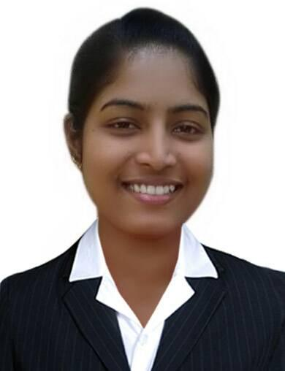

Stefi
Stefi.366338@2freemail.com
To secure position in a fast growing company that will give me an opportunity to create value for the organization by making optimum use of my education, skills & experience.

Date of Birth : 8thMarch 1993
Religion : Christian (Roman Catholic)
Languages Known : English, Hindi, and Kannada.

Educational Qualification :-
H.S.C. from S.K.P.Jr. College, Areangadi, Honnavar, Karnataka University.
S.S.C. from Guru Prasad High School, Mallapur, Honnavar, Karnataka Board.
Professional Qualification :-
Completed Computer Course from St.Angelo’s institute with the Knowledge of HTML, DHTML,CSS, JavaScript, jquery, Photoshop, corel Draw, Flash, Dream weaver and FTP .

Strenghts :-
- Ability to perform under high pressure and cope with ambiguity.
- Excellent communication skills.
- Can handle self correspondence.
- Desire and inquisitive to learn new skills.
- Having positive attitude towards life.

Present Employment :-
In Mash Techsol as a web designer. From 25th April 2016 still date.
Past Employment :-
As a Receptionist in Life Insurance Carporation of India from 2012- 2013 at Honnavar, Karnataka.

Job Profile :-
- Designing Website Layout.
- Converting Photoshop Web layout to HTML.
- Designing broacher & logo.
- Uploading Websites using FTP & Cpanel.
- Managing Company Website and also client Website.
- Keeping peace and harmony into the premises of the company.
The above is true for my knowledge and for better future.

STEFI

