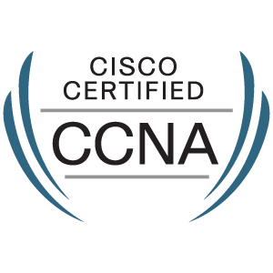 Nagendra
Nagendra.366342@2freemail.com

OBJECTIVE:

Zeal to develop the surrounding where I work, and offer my maximum contribution in terms of effort for its improvement along with the great quest to work in a challenging environment that persuades me to cope with emerging Latest Technologies and scope for broadening my knowledge.

TOTAL EXPERIENCE

2 years 9 months.

- Infosys

Process Executive

Worked for British Telecom ITIL project. Troubleshooting of the connectivity like helping BT engineers to find the port and sync with them also assisting the IT department to fluid the orders.

- Convergys India Services Pvt Ltd.

Process Associate

Worked for EE Broadband process, troubleshooting the broadband connectivity related issues.

KEY QUALIFICATIONS

Cisco Certified Network Associate(CCNA).
Completed Linux Training SA1 & SA2.
Completed Milestone1 for project BT in Infosys.
EDUCATION

BCA | 2010 — 2013
Jain collage
PUC 2 | 2008 — 2010
Gogte College Of Science
SSLC | 2007 — 2008
Gomatesh Vidyapeeth

TECHNICAL SKILLS

Assembling and dissembling of computers.
Installation of operating system for Windows.
Configuration of network and troubleshooting RIP, EIGRP, OSPF.
1
IP addressing.
Knowledge of SA1 and SA2 modules in Linux.
Knowledge of Microsoft office.
PROJECT

- Project done in final year: E-Admission, platform used: .NET, SQL.

POSITION OF RESPONSIBILITIES

First point of contact for escalation handling.
Interacted with the other departments to expedite the work.
Task assignments to the team members.
Taking briefing.
Was a part of employee engagement programs.
Floor supervision.
DECLARATION:

I hereby declare that the above written particulars are true to the best of my knowledge and belief.

2

