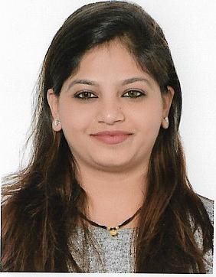
Curriculum Vitae

Personal Details:
Name : Pooja
POOJA.366368@2freemail.com

Objective
Seeking a challenging position in Financial or Administration work environment & to achieve placement in an Organization having global presence.

Academic & Vocational Qualification:

- Bachelor of Commerce (B.com), 2011, Mumbai University, India
- Higher Secondary Certificate, 2008, Mumbai University, India
- Senior Secondary Certificate, 2006, Maharashtra State Board, India

Work Exposure:

Senior Process Associate
Tata Consultancy Services - Nov 6th 2012 - Nov 2nd 2016 Mumbai, India

Joined TCS as a Process Associate, allocated to a Fortune 500 client – Citigroup based in USA and then got internal transferred to the Bank Of America project.
- Was associated with the BOA Doc Upload & Fulfilment team which helps the Underwriter
To identify the documents, this helps smoother completion of underwriting and disbursement.
- Receiving mortgage related documents from Home Service Specialist through email.

- Analyzing the documents and segregate them accordingly.

- Uploading the documents on the E-Doc portal (BOA Application) after doing two point verification

- Labelling the document appropriately as per the labelling verbiage provided by BOA team to help the Underwriter to identify the documents easily.

Previous Process – Loss Mitigation Doc Support

- Previously associated with the Loss-Mitigation Project which deals in minimizing the loss to the Customer and the Bank as well.

- Helping customers to modify the payment plan who are not able to pay their monthly mortgage payments.

- Offer suitable payment plans after reviewing the documents sent by the customer and various other parameters

Team Skills

- Solving Team queries, providing training to the new joiners & also to the existing team members to create proper back up.

- Preparing Daily Productivity, QC and Inflow reports.

HR Associate

Worked with ROYAL BANK OF SCOTLAND (RBS GROUP) from AUG-2011 to MAY-2012 as a HR associate at Lower Parel branch (MUMBAI)

I hereby declare that all the information given above is correct to the best of my knowledge & belief.

