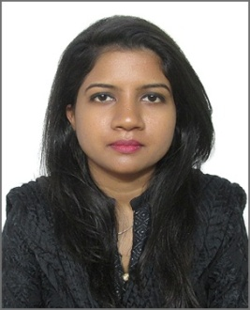
CURRICULUM VITAE

JOSHILA
JOSHILA.366417@2freemail.com

OBJECTIVE

Contribute to the success of an organization by fully utilizing my skills and knowledge that will provide growth in increasing level of responsibility and affiliate with company where my interest, skills and aptitude used to further enhance my qualification and advance.

PERSONAL DETAILS

Visa Status : Visit Visa (Expire on 20th May, 2017)
Gender : Female
Marital Status : Single
Languages Known : English and Urdu (Write & Speak)

EDUCATION QUALIFICATION

- Diploma Computerized Accounting Software
from Noor College of Professional Education Karachi,
2016
- Graduate Bachelor of Commerce
from University of Karachi,
2015
- Intermediate In Commerce
from Govt. Girls Degree College Karachi,
2013

- Matriculation In Computer Science
from Liberal Model School Karachi,
2011
TECHINICAL SKILL

- Diploma in Computer Software and Application
  - Peachtree, QuickBooks, Tally ERP 9 & Advance Excel 2013.
  - Ms Excel, Word, Power point & Outlook.
- Expertise in Cost Accounting:
  - Cost of Manufacturing & Production, Job Order Costing, Payroll, Pay slips, Pay sheets, Vouchers, Pay orders, Assembling & Sales Tax etc.
- Internet Surfing, Outlook, Accounting Software Operating System.

EXPERIENCE

- TUTOR Private of English and Mathematics (Nursery till 10th Grade)
2012 – 2016
- 1 year work experience in Market Group of Associates (As a Sales Executive) in Karachi-Pakistan.
- 1 year work experience in Levi’s Outlet (As a Cashier and Accountant) in Karachi, Pakistan.

LANGUAGE PROFICIENCY

- English Fluent
- Urdu Fluent

DECLARATION

I hereby declare that the particulars furnished above are true to the best of my knowledge and belief.

