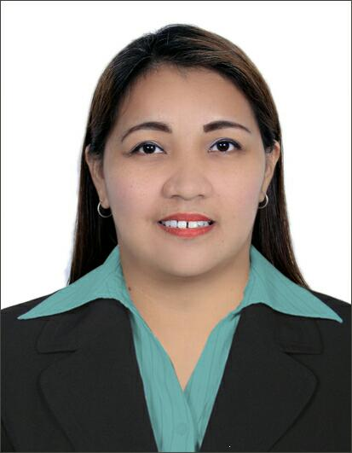
Lorna
Lorna.366428@2freemail.com

OBJECTIVE
- Willing to work in a dynamic, challenging and growth oriented company that allows me to utilize my knowledge and experience to contribute for the growth of the organization. Willing to start immediately.
EMPLOYMENT SKILLS
- Developed ability to work in a fast paced environment
- Ability to follow instructions well
- Delegated responsibilities to employees to meet Company’s expectations
- Sincere, honest, dynamic and hard – working
- Ability to interact with all kinds of people
- Good in oral and written communication and computer literate

EMPLOYMENT HISTORY
BIG APPLE EXPRESS SPA
Level 1, Marquee Mall, Francisco G. Nepo Ave. Pulung Maragul, Angeles City
Front Desk Officer / Receptionist / Supervisor, September 2011 – December 2016
Responsibilities include:
- General Correspondence
- Maintaining and updating files
- Handling incoming and outgoing calls
- Attending clients / customers inquiry
- Banking transactions
- Preparing daily, weekly and monthly financial reports
- Office/spa supplies monitoring
- Daily Time Card checking
- Daily evaluation for the Massage Therapist

HAU ALUMNI ASSOCIATION INC.
2nd Flr. HAU Main Bldg., Sto. Rosario St., Angeles City
Office Secretary/Admin Assistant, January 2009 – May 2011
Responsibilities include:
- General Correspondence
- Maintaining files
- Receiving and sending E-mails
- Updating Alumni Records
- Preparing the minutes of the meeting
- Handling incoming and outgoing calls
- Attending visitors
- Banking transactions such as daily deposits, withdrawals, requesting of bank statements
- Preparing monthly Financial Report and balancing checking account
- Handle accounts receivable, payable and maintain all accounting report
SM CITY CLARK
Clarkfield, Pampanga
Sales Associate / Cashier, February 2008 – December 2008
Responsibilities include:

- Operating cash registers, maintaining an orderly store and helping customers regarding their inquiries.

KAJIMA PHILS. INC.
12th Flr. Makati Sky Plaza Bldg., Ayala Avenue, Makati City
Receptionist /Admin / HR Staff, January 2007 – January 2008
Responsibilities include:
- General Correspondence
- Handling incoming and outgoing calls
- Maintaining and updating files
- Attending visitors
- Bookings (ticket and hotel) for guests
- Office Supplies Monitoring
- Time Card Checking

BCD PINPOINT DIRECT TELEMARKETING INC.
4th Flr. Bloomingdale Bldg., 205 Salcedo St., Legaspi Village, Makati City
Project Telemarketer/Customer Service Representative, January 2006 – January 2007
Responsibilities include:
- Making outgoing calls to market the project handled and to meet quota
- Operates fax machine

EDUCATIONAL BACKGOUND
HOLY ANGEL UNIVERSITY TERTIARY
Sto. Rosario St., Angeles City
Bachelor of Science in Computer Science
S.Y. 2001 - 2005
PERSONAL BACKGROUND
Birthdate November 26, 1983
Place of Birth Concepcion, Tarlac
Civil Status Married
Religion Roman Catholic
Dialects Tagalog, English
Visa Status Tourist Visa

