Muhammad

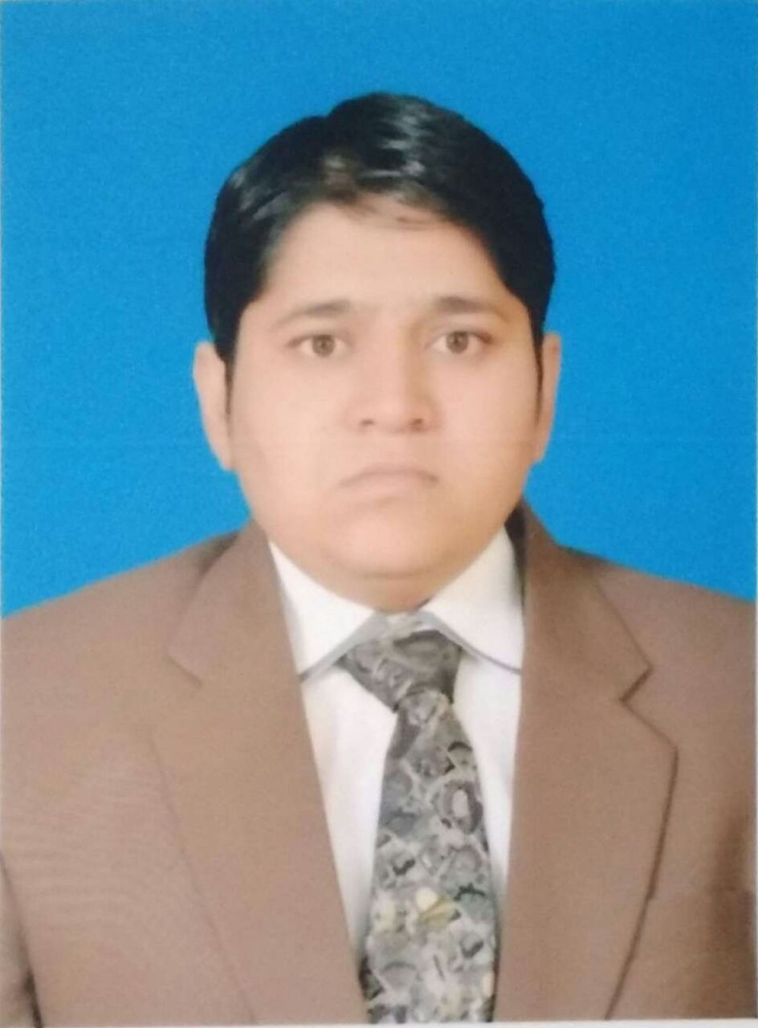
Muhammad.366430@2freemail.com

Objective
Qualified Public Finance Accountant with Master’s Degree in accounting and Finance having more than 7 years professional experience seeking responsible position in a dynamic and growth oriented organization to utilize strong familiarity with International financial reporting standards, International standards on auditing, different accounting software packages as well as forecasted financial statements, tax (VAT) registration, implementation ,compliance, audit and planning skills.

Experience Summary

Working Capital Management Finalization of Accounts as per IFRS  Accounts Receivable Management  Bank Reconciliations  Stock control  Payable Management  Fixed Assets  Forecasted Financial Statements | Management Accounting &Reporting  Internal Audit & Controls  Financial Analysis  Budgeting & Controlling  Inventory Management  Payroll  Audit assessments | Tax (VAT) Registration  Tax (VAT) Implementation  Tax (VAT) Compliance  Assessments of Tax impacts on transactions  Filing of Income Tax Returns, sales tax returns  Handling of Sales Tax Matters(PRA) regarding Punjab Revenue Authority

Skills Summary

Knowledge About ERPs, Tally  Good at Spread Sheets ( MS Excel),  MS Word  MS Power Point | Good Practical Exposure  Strong Conceptual Skills  Good Communication skills  Good at Crunching Numbers | Time Management & Prioritizing  Team Working  Multi-Tasking

Professional Experience

Position Held : Manager Tax, Audit & corporate
Organization : Asif Niaz & Co
Reporting to : Director
Duration : Jan 2015 To Jan 2017 (02 Year 01 Months)
Company Profile : Chartered Accountant Firm involved in Taxation, Internal and External
Audit, Book keeping and Corporate Matters.
Responsibilities:

- Prepared and review Federal and State taxes for individuals, businesses and exempt organizations
- Performed strategic planning for taxes like Sales tax (VAT), Income tax and Punjab Revenue Authority tax
- Managed all tax policies and procedures
- Served as primary contact person for clients manager
- Interacted closely with clients to provide innovative tax planning
- Provided primary and secondary review of complex tax returns of Sales tax (VAT), income tax and Punjab Revenue Authority tax
- Performing tests to check financial information and systems
- Maintaining accounting records and preparing accounts and management information for businesses
- Counseling clients on areas of business improvement
- Managed corporate work with Security and Exchange Commission Of Pakistan whether companies incorporation or secretarial return filing
- Managing trainees
Position Held : Assistant Manager Tax, Audit & corporate
Organization : Asif Niaz & Co
Reporting to : Manager Tax, audit and corporate
Duration : June 2014 to Dec 2014 (07 Months)
Company Profile : Chartered Accountant Firm involved in Taxation, Internal and External
Audit, Book keeping and Corporate Matters.
Responsibilities:

- Assisted with tax audits
- Prepared periodic tax working papers, schedules and reports
- Maintained strong clients relations and cross-sell services within the assigned group of clients
- Filed all tax returns Sales tax ( VAT) , Income tax, Punjab Revenue Authority Returns and collect refunds for excess tax paid
- Assisted clients with questions related to sales tax (VAT), income tax, PRA, property tax filing and registration process
- Prepared tax supported documents
- Conduct tax research to support compliance and planning as required

Position Held : Manager Accounts
Organization : SAFESO INTERNATIONAL
Reporting to : Managing Director
Duration : Feb 2013 – May 2014 (01 Year 04 Months)
Company Profile : Manufacturer, Importer & Exporter of Footwear product

Responsibilities:

Finance & General Accounting, Finalization of Accounts, Budgeting
- Verification of the day-to-day execution of general ledger impacted processes, including support to clients/departments as they work with and understand these processes Submits reports in a timely manner, ensuring delivery deadlines.
- Ensuring accounting functions specifically in the areas of account balancing, ledger reconciliation, reporting and discrepancy resolution.
- Analyzing the monthly and yearly financial balance statements
- Maintains a strong accounting and operational control environment to safeguard assets.
- Verification of Bank Accounts & Bank Reconciliations
- Provide direction and assistance to other organizational units regarding accounting and budgeting policies and procedures, and efficient control and utilization of financial resources.
Accounts Receivable Management
- Followed and checked all Purchase Orders fulfilled in CRM and ensure that ill relevant data has entered and will be received on timely basis.
- Supervised posting of customer payments by recording cash, checks, and credit card transactions.
- Supervised posting of revenues by verifying and entering transactions form lock box and local deposits.
- Protects organization's value by keeping information confidential.
- Adherence to the implemented policies and procedures related to Receivables to ensure standard processes are maintained.
Accounts Payable Management
- Verification Of Account Payable & Payments to Suppliers
- Scheduling of payments to contractors
- Resolved discrepancies in pricing, quantity and product descriptions between invoices and purchase orders. Worked with Purchasing Department to resolve variance.
- Contacted vendors, in coordination with Purchasing Department, in order to obtain account
information and resolve discrepancies.

Position Held : Assistant Manager Accounts
Organization : SAFESO INTERNATIONAL
Reporting to : Accounts Manager
Duration : Sep 2010 – Jan 2013 (02 Year 05 Months)
Company Profile : Manufacturer, Importer & Exporter of Footwear products

Responsibilities:
- Checking and advising all day to day business transactions with respect to their posting in Ledgers
- Preparing Monthly and yearly Balance sheet, Income statement & statement of cash flow
- Managing Bank accounts and preparing Bank reconciliation
- Reconciliation of Clients Ledgers
- Checking trial balance, general ledger and cash book
- Supervise and motivate staff
- Assist manager in organizing, planning and implementing strategies
Achievements:
- Appreciated at work for proficiency in using PeopleSoft and the company’s comparative accounting system
- Proved to be one of the top employees who submitted every due report before time

Position Held : Accountant
Organization : SAFESO INTERNATIONAL
Reporting to : Assistant Manager Accounts
Duration : Oct 2009 – Sep 2010 (11 Months)
Company Profile : Manufacturer, Importer & Exporter of Footwear products

Responsibilities:
- Prepares asset, liability, and capital account entries by compiling and analyzing account information.
- Maintain purchase order processing system
- Prepare labels and maintain files as needed within the department
- Process Accounts Payable paperwork
- Preparing of cash inflow and outflow reports and cash position on daily, weekly and monthly basis.
- Preparing trial balance
- Updating general ledgers and cash book
Achievement:
- Received a pay rise instantly after six months and got promotion as an assistant manager accounts within a year

ACADEMIC EDUCATION:
DEGREE | EXAMINING BODY: | YEAR
Masters in Accounting & Finance | Bahauddin Zakariya university | 2016
Bachelor of commerce | Bahauddin Zakariya university | 2009

CERTIFICATION
- Certified Public Finance Accountant from Pakistan institute of Public Finance Accountant
- 6 weeks computer competence practical Training
PERSONAL INFORMATION:
Date of Birth : 03-06-1989
Religion : Islam

