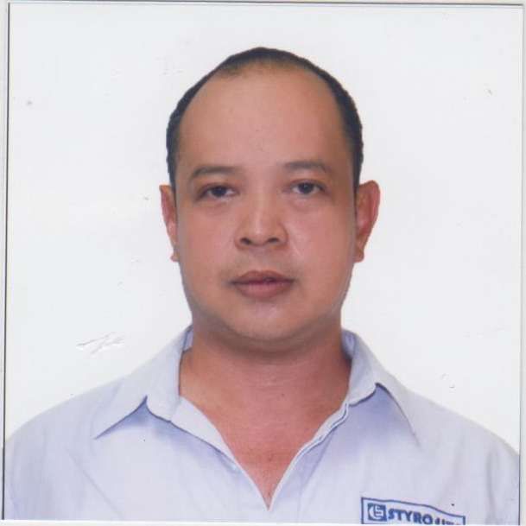
Ariel
Ariel.366461@2freemail.com

OBJECTIVE:
1. To have a challenging position in chemical engineering, where I could apply all major principles and my specialized interested areas of application namely Water treatment and chemical formulations by which I can apply my wide knowledge and professional expertise in the field of chemical engineering and other engineering aspect.
2. To do the balancing act of managing technical processes and teams along with using my technical skills to provide the necessary environment for the company and project success.

EDUCATION: B.S. CHEMICAL ENGINEER
MAPUA Institute of Technology - Batch ‘94

SKILLS:
- Excellent Communication Skills | Cooperative | Time Management Skills
- Excellent Customer Service | Highly Organized | Excellent Personality
- Highly Adaptable | Positive Attitude | Punctuality | Tolerance
- Experience in working in chemical and food Manufacturing Company
- Familiar with GMP, HACCP, OSHE and ISO standard
- Experience in making research for chemical case
- High quality control for chemical products
- Ability to understand tech trends, see how they impact roadmap and how they drive innovation
- Knowledge in operation of chemical laboratory and instruments
- Formulation of new products for development
- Expert on plant operations and equipment ( Boilers, Cooling Tower, Air compressor, air-dryers and other Facility equipments)
- Skills on fabrication of equipment’s (de-mineralize, accumulators, filters}
- Skills on boiler operation and trouble shooting
- Skills in air treatment set up (compressors and dryers)
- High Skills on waste and water treatment operation( Design and Fabrications)
- High expertise on chemical cleaning

WORK EXPERIENCE:
UNIVERSAL ROBINA CORPORATION
Production Supervisor
October 1, 2016 to present
- Ensure effective employee relations. Provide employee coaching and development. Makes employment decisions. Resolve employee issues through problem resolution.
- Balance quality, productivity, cost, safety and morale to achieve positive results in all areas. Work to continuously improve in all areas.
- Manage departmental performance measures, including visual controls and provides regular progress reports to manager.
- Provide leadership through a 30-day planning cycle.
- Manage QDRs.
- Perform accident investigations.
- Maintain proper inventory levels.
- Manage department priorities.
- Track absenteeism and timekeeping.

STYRO-LITE MANUFACTURING CORPORATION (Expandable Polystyrene Products)
Facility, Building and Maintenance Manager
November 2015- September 27, 2016
Job Description
- Design and fabrication of softener unit
- Continuous improvement and introduction of proper process regarding facility operations
- Improvement and Preventive Maintenance of 2 units Boilers, 7 units Cooling towers Air Compressors, pumps and motors and building electrical wiring
- Perform calibration of all facilities
- Rehabilitation of worn out facilities and equipment
- Installation of New air compressor 125 Hp
- Installation of new 150 kw Generator Set
- Installation of 5 units Thermoware cup machines
- Installation of new unit Pre-Expander
- Training boiler and maintenance personnel

March 2015 to November 2015
STYRO-LITE MANUFACTURING CORPORATION (Expandable Polystyrene Products)
Consultant/Technical Manager
Job Description
- Perform Plant Balance (Water, Steam electricity and air)
- Recommendation of system for Plants Maximum Efficiency
- Responsible for project planning, setting targets and deliverables
- Implementation of Standard working procedure
- Use measuring device to ensure quality control
- Lead teams’ technological activities
- Provide the necessary environment for project success

January 2014 to February 2015
AMP CHEMICAL SALES AND INDUSTRIAL SERVICES – partnership business
General contractor
Projects: Plant Expansion for Stylolite Manufacturing Corp
- Design Fabrication and installation of 12 Mt capacity Steam accumulator
- Design Fabrication and Installation of Steam line, Compressed airline and water for 8 units Behl Shape machines
- Design of all pipe lines from boiler to steam accumulator to BS Machines
- Construction of Foundation for 8 units B.S Machine
- Re-tubing of 8Mt Capacity Boiler [Coal Fired]
- Installation of 4 Mt capacity Boiler

2007 -2013
PLM Chemical Corporation
Operations Manager
- Projects: Planning and controlling change.
- Managing quality assurance programmed.
- Researching new technologies and alternative methods of efficiency.
- Setting and reviewing budgets and managing cost.
- Formulation and compounding of new products
- Overseeing Inventory, distribution of goods and facility
Projects Handled
- Hitachi Babcock Steam Flushing - June 2013
- Biscom Evaporator and heaters Chemical Cleaning - April 2013
- CADP Chemical Cleaning of Evaporators - November 2012
- Sagay Central Boiler chemical cleaning - May 2012
- First Farmers Pan accelerator chemical cleaning - March 2012
- Central Azucarera Don Pedro chemical
Cleaning evaporators and pan accelerator - October 2011
- Hitachi Babcock Boiler Chemical Cleaning - 2010

1997 to 2007
Legaspi Import and Export Corporation / Solid State Multi-Products
Sales Engineer (Jobs include)
- Complete understanding of pricing and proposal models.
- Acceptance of imported Liquid chemical (solvents) from Tanker ships to Storage tank methods of analysis thru:
-Sounding (Volume)
-Titration (% concentration)
- Knowledgeable in dealing INDENT and LOCAL sales thru:
-Letter of Credit at sight / Documents against Payment / Telegraphic Transfer / Local
Sales and Forward sales
- Attended meetings with clients and principal and conveyed their requirements to management.
- Worked closely with Sales Managers.
- Researched the market with the help of the production team.
- Assisted in price/cost assessments within the department.
- Attended meetings with supplier’s principal and customers.
- Prepared sales reports.
- Supply and service Nanya CCL to Deduck (1999-2007)
- Trained new sales engineer
ACHIEVEMENTS
- Achieved sales goals dependably, according to company business plan.
- Developed and maintained relationships with prospective and existing clients.
- Had the highest sales record by LIEC sales engineer a total of 60 containers in one month
1994 to 1997
Atom Industrial Sales and Services
Production Supervisor/Laboratory Supervisor (job includes)
- Prepare a healthy and safe working environment for production staff and the whole plant
- Assure that products passed QC before releasing
- Calibration and standardization of laboratory instrument and apparatus
- Research and development of new products and improvement of existing products for client’s consumption
- Handles waste and water treatment operation and constantly improving the system
- Commissioning of Lang Hua Splash Demineralised Water System at Lang Hua Splash Development LTD Fujian Shen Jinjiang Shi Yingling Chen Yinglin Tsun Sing Lu, P.R.O.C. China (November 1996)
- Toll Manufacturing of different brands of Bath Soap, Powder detergents and liquid surfactants.

PERSONAL DATA:
Birthday: May 17, 1972
Status: Married with 2 children (15 & 10)

