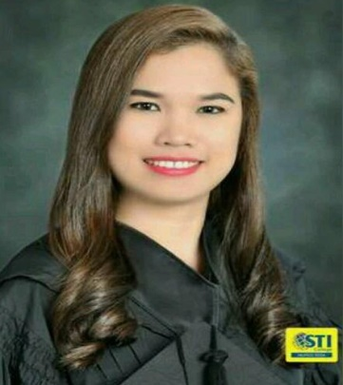
Syrrene

Syrrene.366478@2freemail.com

CAREER OBJECTIVE:
To obtain the position that will fit to my qualifications that will help to develop my skills and knowledge for continuous career improvement in hospitality industry.

EDUCATIONAL BACKGROUND
Tertiary: Hotel and Restaurant Administration
STI College Muñoz EDSA
Tanco-cu Bldg., EDSA Quezon City
2010-2016

Secondary: Sta. Teresita National High School
Sta. Teresita, Batangas
2006-2010
SKILLS:
- Excellent in Front Office and Clerical Duties
- Committed, hardworking, with sense of professionalism
- Confident attitude to proactive approach to work
- Highly versatile to people, adjust easily to situation, can work under less supervision and stressful situations
- Computer Literate : Microsoft Office and the Internet
JOB EXPERIENCE:

Front Office Receptionist
Country Club Hotel
Bur Dubai Mankhol
December 2016 – March 2017

Duties and Responsibilities:
- Welcoming the guests and provide quality service to meet their needs
- Attend incoming enquiry calls with regard to hotel reservations and other hotel services
- Coordinate with Housekeeping Department to make sure that rooms are properly cleaned for hotel guests occupancy
- Responsible in keeping records pertinent to the daily operation of the organization

Front Office Receptionist
Albergus Catering
16 Capitol Hills Drive, Old Balara, Quezon City
May – October 2016

Duties & Responsibilities:
- Carry out clerical and administrative duties efficiently for various departments including correspondence, logistics coordination, customer relations and supplier dealings
- Cater visitors’ enquiries in relation to the Company’s nature of business by phone, email or in person
- Attend incoming calls and conduct follow-ups on matters pertinent to daily
Operations
- Responsible in keeping records pertinent to the daily operation of the organization

On-the-Job Trainee
Front Office Department
Rembrandt Hotel
Tomas Morato Ave., Quezon City
December 2015 - February 2016
Duties & Responsibilities:
- Meet and greet hotel guests and provide quality service to meet their needs
- Attend incoming enquiry calls with regard to hotel reservations and other hotel services
- Assist in room reservation of hotel guests from phone calls and walk-in
- Coordinate with Housekeeping Department to make sure that rooms are properly cleaned for hotel guests occupancy

National Certificates II
- Food & Beverage Services II
- Housekeeping II
- Cookery II
PERSONAL PROFILE:
Date of Birth: July 27, 1994
Place of Birth: Sta. Teresita, Batangas
Age: 22
Citizenship: Filipino
Religion: Roman Catholic
Visa Status: Tourist Visa (Valid Until July 12, 2017)
Notice Period: Immediate

Available upon request

I hereby certify that the above information is true and correct to the best of my knowledge and belief.

