SHIV SHIV.366513@2freemail.com
DATE OF AVAILABILTY IN DUBAI: 1ST MAY TO 25TH MAY 2017

Quality/site engineer with +6 years of experience in Pipeline,Civil, Construction, Estimation and O&M I am good in utilizing my Management, Supervision & Engineering skills to benefit growth and success to an organisation.

EXPERIENCE
SUEZ---------------------------------------------------OCT 2014 TO JUNE 2016 Pilot project for improving the efficiency of Water Supply in Command Area comes under Malviya Nagar Underground Reservoir Delhi. (MNWS - Delhi Jal Board).
QUALITY/ SITE ENGINEER
- Supervising of construction and maintenance of pipelines and fittings.
- I was on the routine checks with my supervisors to insect the progress of construction works (House Service Connection) going on the sites by using the right material (MDPE pipe and Fittings).
- Restoration work using the material like PCC and Paver tile.
- Construction of HDPE & MDPE PIPELINE.
- Adhered to safety measures in all operations.
- Preparation of Joint measurement report with certification from Client.
- Customer handling at site.

JMD ENTERPRISES-------------------------JULY 2012 TO AUGUST 2014
Construction and Maintenance of Indian Oil Corp. Ltd. petrol pumps in Delhi and Haryana State.
SITE ENGINEER
- Construction, Commissioning and Decommissioning of petrol pumps
- Document controlling (Tenders).
- Erection of MS pipeline.
- Above/ underground tank installation (MS- 20 KL to 70 KL).
- Brick masonry, RCC, PCC and steel structure work.
- Estimation of Project.
- Billing certification from authority officers.

O.M.ENGINEERING WORKS------------------APRIL 2010 TO MAY 2012
Annual maintenance contract for Railways Consumer Department.
SUPERVISOR
- Maintenance of (MS pipeline and Pumps).
- Document controlling (Tenders)
- Joint measurements and certification with clients.
- Procurement.
- Estimation of project.

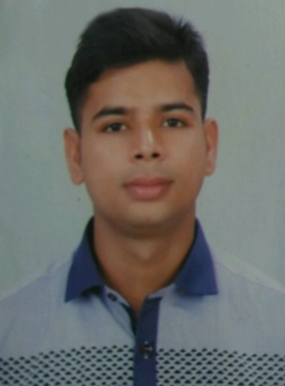

SKILLS

- Site management.
- Pipeline construction (HDPE, MDPE, MS, AND GI)
- Civil Construction (Brick masonry, RCC, and PCC).
- Operation and maintenance.
- Document contrilling.
- Estimation.
- MS Office
- CAD 2D

ACADEMICS

Secondary school-------------2005(C.B.S.E)
Diploma ECE--------------------2008(I.A.S.E)

CERTIFICATIONS

Project Management--------2015(IACT)
Lean six sigma----------------2015(IACT)

TRAININGS

- 15 Days training in SALES from LG ELECTRONICS, Delhi.

- 1 month training in R.K.ENGINEERS.

PROJECT WORK
- Construction of petrol pump (COCO Connaught Place, Delhi-etc).

- Pilot project for improving the efficiency of Water Supply in Command Area comes under Malviya nagar UGR.

DECLARATION

I hereby, declare that the details furnished above are correct and true to the best of my knowledge and belief.

DATE:

PERSONAL DETAILS
Date of Birth----------08 January 1989
Sex----------------------male
Marital Status---------Married
Nationality------------Indian
Language--------------English, Hindi,
Punjabi
Hobbies----------------Singing & Dancing

