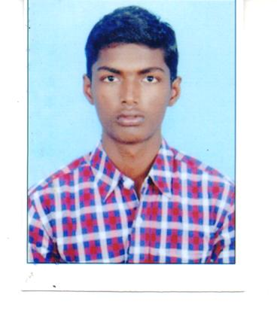
RESUME
VELUSAMY
VELUSAMY.366518@2freemail.com

CAREER OBJECTIVE:
- To make positive contribution as part of your dynamic and well reputed organization in a position where my management, decision making and communication skills will be appreciated and enhanced.
- Seeking for opportunities and secure a position to contribute my skills effectively for the growth of the organization and my professional career.
EDUCATION QUALIFICATION :
Qualification | Institute/University | Year of passing | Percentage
BBA | National College,Trichy | 2016 | 72.50%
HSC | Govt. Higher Sec School,  Nainarpalayam | 2013 | 63.08%
SSLC | Govt. Higher Sec School,  Karunthalakurichi | 2011 | 75.40%

EXPERIENCE:
My Cute Mini, Chennai, Tamil nadu,India
As a “Business Development executive”, June 2016-Feb 2017.
- Developed and Implemented business plans making for organization.
- Managed payments and accounts receivable processing online payments.
- Maintained good relationships with customers and clients.
- Ability to identify ,and develop business strategies to expand the current business.
- Great at interpersonal commnunication,effective coordinator,energetic ,upbeat personalities and analytical abilities.
- Identifying the specific needs of customers,then creating well solutions for them.
- Seeking out and ability to chase up new business opportunities.

PROJECT REPORT:
- Study on employee job satisfactions with special reference to
“Reliance Mart”.
- To study the employee perception and attitude towards organization and their works.
- To identify the factors that motivates the employees.
SKILLS SETS:
- Ms- Office
- Basic knowledge of computer and Internet surfing.
INTEREST & HOBBIES
- Watching movies, Listening to music, Games.
EXTRA CURRICULAR ACTIVITY:
- Member of Junior Chamber International at my college
- Served as the Class Representative during 2013-16.

DECLARATION:
I do hereby declare that the above information is true to the best of my knowledge.If given opportunity,I will strain to do my best for the organization.

