Curriculum vitae

NISHMA
NISHMA.366538@2freemail.com
Personal Profile:  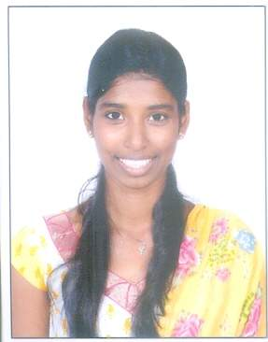 | Career Objective:  Obtaining the position of a biology/ zoology/Chemistry teacher in an organisation that will offer me an opportunity to share my knowledge and skills for the growth of an organisation.  Work Experience:  2 year of teaching experience, Baliyoor Jamathul English Medium School (4 months) and kanachur Public CBSE school (5 months) and Shihabs English Medium school (1 year).  SYNOPSIS OF SKILLS  - Profound knowledge of biology  - Excellent communication and written skills  - Ability to experiment on different sections of biology  - Capacity to research and problem solving attitude  - Highly skilled in analyzing the subject to the students as well as an ability to use different methods of teaching  - Ability to motivate students and guide them for better results  - Good organisational skills and ability to arrange the sessions for student.  - Ability to maintain good relationship with students.  extra curricular  Seminars attended:  1. Worksop on “vermitechnology- Identification Of Local Earthworm Species” (2011).  2. National Level Seminar on “Recent Advances In Biological Sciences” (2012).  3. The National Seminar on “Microbes- Diversity And Their Implications” (2012).  4. Seminar on “Indian cow breeds- current perspective and conservation programme” (2014).  5. National level Conference on Recent Advances in Animal Sciences (national level 2015).  educational qualification  Course/ Degree University Year of Passing Percentage Obtained  Class X Kunil EducationTrust School 2007 64.4%  PUC St. Aloysius PU college 2009 59.0%  B.Sc St.Aloysius Degree College 2012 69.6%  B.Ed St.Anns College of Education 2013 72.3%  M.Sc Mangalore University 2016 68.0%

Personal Interests:  - Singing  - Travelling  - Painting  - Dancing  - Sports  Personal Strengths:  - Fast Leaner, adapt well to changes and pressures in workplace.  - Work effectively with diverse group of people.  - Ambitious, hardworking and committed to excellence. | PROFESSIONAL QUALIFICATIONS:  - Bachelor Of Education (B.Ed), Biological and Physical Science, 2012-2013, St. Anns College of Education, Mangalore  - Masters of Science (M.sc), Applied Zoology, 2014-2016  Mangalore University, Mangalagangothri  subjects and technical proficiency  Subjects known:  Molecular biology, Biochemistry, Animal systematic, physiology, toxicology &cancer biology, Adaptation biology, Anatomy, Genetics, Immunology, Fisheries, Animal Breeding, Parasitology, biodiversity &conservation, Nutrition & metabolism, Neurobiology & animal behaviour, Animal cell biotechnology(P.G. level). Botany and chemistry, Physical and Health Education (U.G. level).  Techniques known:  RID, ELISA, Ouchterlony, Electrophoresis techniques, Tissue culture, permanent slide preparation and basic experimental techniques.  Computer skills:  C Language, Windows operating systems, Internet, Email/MS Outlook, MS office, Photoshop, Movie maker.  Declaration :  I hereby declare that the information provided is true to the best of my knowledge.

