CURRICULUM VITAE

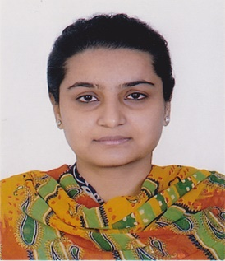
MANJULA
MANJULA.366539@2freemail.com

---------------------------------------------------------------------------------------------------------
CAREER OBJECTIVE:

A growth oriented position in a dynamic and professionally managed organization which provides opportunities and challenging environment for development and responsibilities to contribute towards success.

EDUCATIONAL QUALIFICATION:

Class 10th passed in session 2006 from CBSE .
Class 12th passed in session 2008 from CBSE.
Diploma of Architectural Assistantship passed in session 2008-2011 from
Punjab State Board of Technical Education and Industrial Training.
Graduation (B.A) passed in session 2012-2015 from Panjab University.

WORK EXPERIENCE:

Worked at EVOLVE ARCHITECTURE, MDC-Panchkula from October, 2011 to October, 2015.

P0SITION:
Architectural draftsman.

JOB DESCRIPTION:

- Prepare Working Drawings and Detail such as general arrangements, Plans, Elevations, Detailing and all Architectural Drawings & Interior Design.
- Preparation of complete Architectural Drawings based on Client requirements.
- Preparation of Presentation Drawings by using Autocad Software .
- Provides daily updates on work in progress.
- Organizes and Maintain Drawing files in proper order and condition for future retrieval & use.
- Perform other Duties as assigned.

LANGUAGES KNOWN:

- English
- Hindi
- Punjabi

STRENGTHS:

- Strong Interpersonal Skills
- Punctuality
- Humble, Sincere & Honest

COMPUTER SKILLS:

- MS DOS
- MICROSOFT OFFICE: (WORD, EXCEL, POWERPOINT)
- Auto Cad 2007,2010

DECLARATION: I hereby declare that all the above mentioned details are true and correct as per my knowledge.

