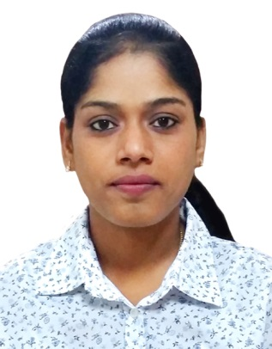

DAMIYA

DAMIYA.366548@2freemail.com

Career Objective

To seek a position to utilize my skills and abilities in a place that offers me Career Advancement and Professional Growth.

Professional Experience

Emirates NBD Private Banking Oct 2015 till March 2016
Processing Team Member
Compliance Remediation project for Private Banking.
- Account reviewing (Gap Analysis) – analyzing gaps in requirements for corporate and individual clients (these include the KYC/CDD forms, identification documents,
World-check searches) and communication with RMS to obtain the same
- Identification and categorization of high –risk accounts (pertaining to updates in compliance high risk policies and procedures)
- Coordinate with the Private banking team Relationship Managers for collection of relevant KYC docs which needs to be updated in the accounts
- FINACLE updates for the remediation documents received from RM
- Execute World Checks and Google checks of UBO’s, Signatories, POA’s and Shareholders

Account Maintenance:
Account Activation, Updating of Passport, Visa, and EID & Trade License, Updating of Change of Address, Contact number & Email, Adding POA , Preparing Reference Letter, Balance Confirmation letter, Good Conduct Letter, Audit Confirmation Letter & Closure Confirmation Letter upon Clients and Auditors request, Debit Card Issue, Corporate Salary Account Activation, ECB , Telephone & Fax Indemnity, Issue of Cheque Book Request, Fatca Updating

RBS (The Royal Bank of Scotland), Chennai, India Mar 2011 - Dec2014
Senior Process Associate - Trade Finance Operations

Job Responsibilities:

- Letter of Credit - Bill handling for UK customers in Imports & Exports under UCP600
- Routing MT734, MT756, MT202 and other SWIFT messages related to L.C
- International Settlement
- Investigation of any enquiries encountered concerning transactions with counter parties for non-receipt of funds, duplicate payments, non-payment and resolution of such discrepancies promptly
- Issuance of Import / Export under Trade Collection
- Import / Export Bills Discounts, Payments, Negotiation under Letter of credit
- Investigating the entire products in L.C & Collections
- Managing Reports to investigate on incoming/outgoing Funds
- Provide corporate clients with the financial products e.g. LC financing
- Performing other operational activities as assigned by Head of Credit

Achievements

- Secured best Outgoing student Award in HSC.

- Our team won 1st price in the Intra college competition in a Management Meet – MBA, in Business games competition under my lead.
- Secured Distinction in TSA 1- Trade Skill Assessment levels internally conducted in RBS Business Services Private Limited
- Cleared Authorizer Test in first attempt

Computer Skills

- MS Office , C, C++, Oracle, Tally

- Operating Systems: Windows.

Educational Qualifications

Master of Business Administration (Finance/HR) June 2009 – April 2011
Sathyabama University, Tamil Nadu, India
Bachelor of Science (Physics) June 2006 – April 2009
Stella Maris College, Tamil Nadu, India

Higher Secondary School June 2005 – April 2006
Holy Angels Matric. Hr. Secondary School, Tamil Nadu, India

Personal Particulars

- Date of Birth: 14th April 1988
- Marital Status: Married
- Nationality: Indian
- Languages Known: English, Hindi(Read &Write) and Tamil
- Visa Status: Residence visa (Husband)
- References: Available upon request

Declaration:

I declare the above given details are true to my best care and knowledge and are subjected to verification for genuineness.

