LUKWAGO 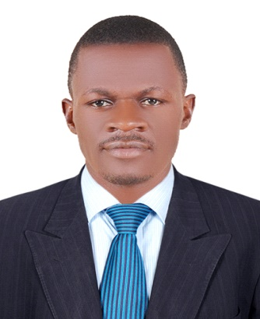
Dubai, United Arab Emirates
Email: LUKWAGO.366564@2freemail.com
Nationality: Ugandan
Visa status : Visit Visa
Availability: Immediate

Career Objectives.
Looking to advance my career through an opportunity in the company as a Senior Electrical technician using the vast experience in the electrical industry.
To utilise my talent in preserving the condition and repairing the electrical and electronic equipment, checking their wear and tear from time to time and maintain the efficiency of the various power lines in the organisation without any interuption of the work procedure.
Career Summary
I am a self motivated, hard working electrician with more than 7 years industrial and overhead lines, installation and maintainance experience. I have exceptional technical ability to work across a broad range of systems and thus i pride myself on the impeccable quality of my work. My excellent interpersional skills make me a good team member as well as an effective leader. I adhere to the systems and industial regulations at all times and enjoy keeping up to date with the latest electronic technology and innovation.
Education.
Dons College of Applied Technology and Business Studies, Makerere.
Certificate in Electrical Installation. Graduated: 2010
Kakungulu High School, Bombo.
Uganda Advanced Certificate of Education (UACE) Graduated:2001
Certified by the ministry of foreign affairs. 2017
Kakungulu High School, Bombo
Uganda Certificate of Education (UCE) Graduated: 1999
Certified by the ministry of foreign affairs. 2017
Employment History
Nek consults 2012 to 2017
Field supervisor and linesman
Resonsibilities.
Mantaining records and preparing reports for administrative work.
Ensuring that the team that is going to operate in the field is fully healthy and equiped with PPE through daily morning briefs and check ups.
Achievement
Commended for customer service skills
Promoted to head Electricians and the junior staff at district level.
Umeme ltd: 2010
Lugogo yard. Overhead & maintenance linesman
Responsibilities:
Installing new electrical HV and LV lines.
Maintaining and repairing installd electric lines like replacing broken poles and conductors.
Training new staff about the company goals and strategies.
Achievements.
Promoted to Senior Overhead linesman.
Other activities and Awards
Driving with a local lisenced permit
Acknowledged and Certified at almost every organisation for my entusiasm at work.
Learning and adapting to new technologies
Volunteering
Sports (Football, Athletics Swimming, Volleyball, Draft, Chess).

Academic documments and other awards will be presented following the company call.

