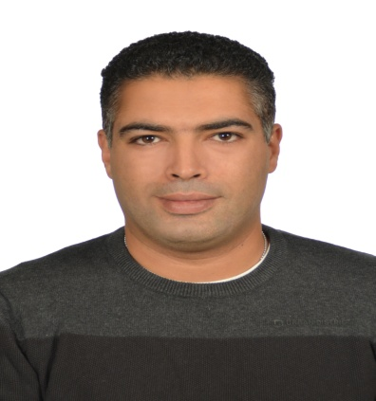

|  |  |  |  |
| --- | --- | --- | --- |
| |  | | --- | | **Walid**  [**Walid.366578@2freemail.com**](mailto:Walid.366578@2freemail.com) | |  | |  |
|  | |
| |  | | --- | | **Profile** | | |  |  | | --- | --- | | **Objective:** | Electrical Engineer with more than ten years experience in Maintenance Electrical and Mechanical field, specially (Generators, Pumps, Oil fired Boilers, and Compressors with different types). Also have good experience in maintenance of AC systems and Refrigerator systems.  I got **BS.c of Electronics and Communication engineer** at 2004, and **Certified as Chief Marine Engineer**.  Self motivated, Energetic, Self learning, looking for perfection at work and as life style. willing to learn and adopt new systems, rules, and technology to be at professional level. | |  |  | | | |
|  | |
| |  | | --- | | **Education** | | * **2015:** Certified as Chief Engineer from The Arab Academy for Science and Technology(AAST) * **2010:** Certified as Second Marine Engineer from The Arab Academy for Science and Technology(AAST) * **2007:** Certified as Third Marine Engineer from The Arab Academy for Science and Technology(AAST) * **2004:** BSc degree of Electronics and Communication engineering from Alexandria Institute of Technology(AIT) * **1998:** Graduated from High School “Victory College”, Alexandria. | | |
| |  | | --- | | **Work Experience** | | * ***(20/03/2016) up till now:*  Mechanical Engineer (Ship maintenance) at NATIONAL MARINE DREDGEING COMPANY (NMDC).** * **(01/6/2012 to 01/03/206):**  ***Mechanical engineer at United Arab Shipping Company (UASC) .***   **Mechanical and Electrical maintenance** of Generators, Alternator, Oil fired Boiler, and compressor, Diesel engine for Life boat and fast rescue boat.  Fuel injection system and lubricating system for the diesel engine.  **Responsible for safety and hazard** in the engine room.  Types of Chemical would be used on board and types of lubrication oil for different types of equipment.  Monitoring and developing the condition of all equipment on board to get better performance at running condition.  Confirming that the ISM rules are applied on board (different types of risk assessment).  Planning and Supervising the work to be done by engineers, fitter and motorman for every month.  Supervise the work done by the workshops or Dry docks and make reports to the company.   * **01/09/2010 to 30/5/2012: *Electromechanical engineer in solar energy plane project at Egypt- Japan University of Science and Technology (E-JUST)***     Electro-mechanical engineer in solar energy project at Egypt- Japan University of Science and Technology (E-JUST).  making researches for the best types of Photo- Voltaic cells to be used on the plant.  co-coordinating between the Egyptian government ( west Delta Electric company) and the Japanese side for how two merge our planet with their network.  planning how to connect the solar planet with the local electrical network.  preparing researches for different types of transformer to be used in the planet.   * **1/11/2008 to 31/1/2010:** Marine engineer at National Navigation Company (NNC).   **Mechanical and Electrical Maintenance** of Generators, Oil fired Boiler, and emergency Air compressor, diesel engine for Life boat and fast rescue boat, Fuel injection system and lubricating system for the diesel engine.  responsible for safety and hazard in the engine room, types of Chemical would be used on board and types of lubrication oil for different types of equipment.  monitoring and developing the condition of all equipment on board to get better performance at running condition.  confirming that the ISM rules are applied on board (different types of risk assessment).   * **1/10/2007 to 5/10/2008:** Marine engineer at National Navigation and Investment Company(NNIC):   Mechanical and Electrical Maintenance for Compressors, and purifiers.  Planning for fuel oil and lubricating oil bunkering.  Assisting in maintenance of Diesel engines, Generator and all other auxiliary equipment.   * **14\5\2006 to 20\12\2006:** Electrical engineer at The International Associated Cargo Carrier Company “IACC”:   **Monitoring and Maintenance** of all running motors on board.  Maintenance of the electronic equipment for navigation, and their back up system.  Monitoring and developing the battery room and supervising the safety standard for it.   * **1\08\2005 to 1\04\2006:** Direct sales for SME companies at **Vodafone Egypt**.   Managing Deals with SME companies to provide them with calls and internet services.  following up with the current customer to solve any complains from their side, and find new customer for our services. |  |  | | --- | | **Additional Courses** | | * Certified as a Class Survey from the Arab Academy for Science and Technology (AAST). * “PMP” Course. * “Soft Skills” Course. | | |
| |  | | --- | | **Languages and computer skills** | | * **Arabic:** mother tongue * **English:** fluent * **French:** fair * **Computer skills:** Microsoft Office package (Word, Power point, Excel) and Internet surfing, I also attended “MCSE” & “CCNA” course and “A+” course. |  |  | | --- | | **Activities and Interests** | | * Reading novels. * Internet surfing. * Traveling * Member at Smouha and Alexandria Sporting clubs. * Member of Engineering Egyptian Syndicate. * Member of IEEE Organization. | | |
| |  | | --- | | **References** | | Available upon request | | |
|  | |