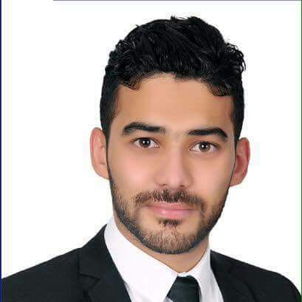
AHMED
AHMED.366586@2freemail.com

OBJECTIVE

I am looking for an opportunity in a reputed organization which will help me deliver my best and upgrade my skills in engineering and meet the demands of the organization.

ACADEMIC QUALIFICATION

Bachelor of Civil Engineering
Delta University- EG- Faculty of Engineering
Egypt
Date Graduated – May 2015

PROFESSIONAL EXPERIENCE

Position : Project Engineer
Company : UR Contracting L.C.C / PO Box 64180, Dubai, U.A.E
Project : G+4+R Labour Camp Accomodation on Plot No. 599-9117 at
Jebel Ali Industrial Area 1 – Site Engineer
Project : Proposed G+1 Private Villa Plot No. 616-2782, at Nadd Al
Shibba 3, Dubai, U.A.E – Project Engineer
Duration : Febuary 2017 – Present

Responisibilities Include:
- Follow-up all site works and labors.
- Preparation for daily reports, weekly reports and drops in time schedule.
- Monitor labor attendance.
- Preparation for Look A Head schedule.
- Make material request, follow-up materials supplied and comparing it with specifications.
_____________________________________________________________________________________________________

Position : Site Engineer
Company : Mechanical Contractirng Company and Foundation
Cairo, Egypt
Project : Expansions Dringking Water Station Gamasa (Soil Borings)
Constrcution of residential buildings (1Building)
Duration : June 2016 – December 2016

Responisibilities Include:
- Follow-up all works (steelwork,pouring, insulation and etc.)
- Follow-up materials supplied and comparing it with specifications.
- Achieve the required specifications as much as possible.
- Preparation of daily reports and drops it in the time schedule.
- Preparation of weekly reports and discussion of problems.

_____________________________________________________________________________________________________
Position : Site Engineer (Training)
Company : Solaiman A. El Kherreiji Consultant (SAK)
Jeddah, KSA
Project : Construction of residential buildings (2Buildings)
Duration : February 2016 – May 2016

Responsibilities Include:
- Follow-up all works (steel work, Form work, Pouring, Insulation, And Etc.)
- Follow-up materials supplied and comparing it with specifications.
- Achieve the required specifications as much as possible.
- Preparation of daily reports and drop it in the time schedule
- Preparation od weekly reports and discussion of problems.
- Review of construction plans and workshop drawings.
_____________________________________________________________________________________________________

Position : Site Engineer (Training)
Company : ICPW Irrigation Company for Public Works
Sinai, Egypt
Project : Sinai Sector Company Site Socket 4
Duration : July 2014 – September 2014

Responsibilities Include:
- Experience working in the executive and how to deal with the design and implementation problems.
_____________________________________________________________________________________________________
TRAININGS:

- Auto CAD 2D
- SAP
- Safe
- Etab’s
- CSI Column
- Microsoft Office
_____________________________________________________________________________________________________

PERSONAL DETAILS:

Date of Birth : 29th January 1992
Nationality : Egyptian
Gender : Male
Civil Status : Single
Language : Arabic and English
Religion : Muslim

I HEREBY that all information provided are true and correct to the best of my Knowledge and belief.

