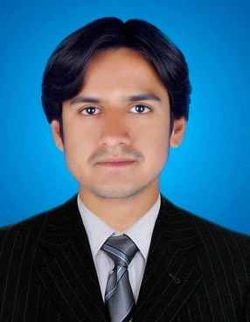HAMEER
HAMEER.366601@2freemail.com

Career Objective

I am a young & energetic professional with almost five years of experience. I am looking forward to join a progressive organization, where I can pursue a successful career by utilizing my skills and abilities up to the maximum extent with full potential. My major experience explored the field of Sales & Marketing, Customer Service. I do believe in excellent achievement through customer satisfaction.

Personal Information
Date of Birth : 07-03-1992
Nationality : Pakistani
Validity : 02/12/2020
Work Experience
2014 -2016
(SINDH AGRICULTURE UNIVERSITY TANDO JAM)
(Computer Operator )
Designation:
My responsibilities are as follows:
- Internet Browsing
- Hardware Management
- Software installation

2016 – 2017

Company Name: (PTCL)

Designation: (Sales Representative)
My job responsibilities were as follows:
- To promote the product of the company in retail.
- Set up and arrange display to attract attention of prospective customers.
- Suggest product improvements to management and product to purchase to customers.
- Developed and promoted brand awareness with all potential customers within assigned territory.
- Conducted product knowledge and other training classes for customers as needed.
- Maintaining monthly sales target.
- Maximizing number of customers by good communication skills.
- Provide complete Support and assistance to the customers.

2010 – 2012

Company Name: (Haier)
(Hyderabad Pakistan)
Designation: (Sales Representative)
My job responsibilities were as follows:
- To promote the product of the company in retail.
- Set up and arrange display to attract attention of prospective customers.
- Suggest product improvements to management and product to purchase to customers.
- Developed and promoted brand awareness with all potential customers within assigned territory.
- Conducted product knowledge and other training classes for customers as needed.
- Maintaining monthly sales target.
- Maximizing number of customers by good communication skills.
- Provide complete Support and assistance to the customers.

Education
- Matriculation  - Intermediate | Years – 2006-2008  Years -2008-2010 | (Board of Matriculation Secondary Education Sukkur) (Board of Intermediate Secondary Education Sukkur)
- Bachelor | Years- 2012-2014 | (Shah Abdul Latif University Khairpur)

Computer Skills
- Microsoft office
- (Word, excel, power point, One note, Publisher)
- Operating System
- Windows XP, Window7,Windows8, Windows10)
Languages
English , Urdu, Sindhi,. (Fluent in speaking, writing and reading )
Factors
- Proactive & Fast learner with strong communication.
- Strong interpersonal skills.
- Ability to complete assigned tasks in committed time.
- Decision making skills.
- Work hard and fast learner.
- Challenge Oriented

