CURRICULUM VITAE Aleksandra

Aleksandra.366619@2freemail.com |  | 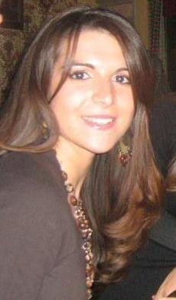

Work Experience
- November 2014- Etihad Airways
Guest services department, Cabin crew

- Providing excellent customer service to passengers while ensuring their comfort and safety throughout the flight

- Dealing with medical emergency situations and first aid administration

- February 2013- November 2014 »Irisfarm« Pharmacy Novi Sad
Pharmacist in charge

- Ensuring compliance with all applicable laws and regulations for a respective pharmacy

- Functional supervision and staff support

- Procuring and dispensing prescribed medicines and medical supplements, selling cosmetic products and medical devices

- Cusotomer care and providing necessery information and advice

- Performing all related duties as required

- September 2012- February 2013 »Irisfarm« Pharmacy Novi Sad
Pharmacist

- Dispensing prescribed medicines and medical supplements, selling cosmetic products and medical devices

- Cusotomer care and providing neccessery information and advice

- Organising laboratory work and prepairing galenic and magistral formulations, procuring and control of incoming chemicals

- September 2011 – September 2012 Private tutor for chemistry and biology for high school students

- September 2011- September 2012 Carried on apprenticeship, passed professional state exam and obtained valid Pharmacist licence

Education
- July 2011 Master of Pharmacy Degree
Graduate Work: “ Extraction and determination of purin alcaloids in Maté
(Ilex paraguariensis)”

- 2006 - 2011 Medical Faculty Novi Sad, department of Pharmacy
The average score: 9.39

- 2002-2006 Medical School “7.april” Novi Sad, pharmaceutical technician

Abilities
- PC work: Microsoft Office and Internet

- Foreign languages: English - fluent written and spoken
Serbian-native

- UAE driving licence and total of 12 years of driving experience

Personal characteristics and interests
- communicative, open-minded and very comfortable with working in multicultural enviroment
- good team player
- punctual, reliable and hardworking
- ready to learn and acomplish new tasks and goals
- rollerskating, cycling, books, travel

