Salma

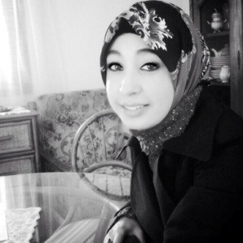

Skills

- Teaching English as a foreign language.
- Communication skills
- Team management

Backgrounds

*Literature( drama, poetry, fiction and Anglo-Saxon literature)
* Civilization ( British and American history)
* Linguistics
* teaching pedagogy and methodology
Salma.366625@2freemail.com
Academic experience

2012-2013: Diploma: Bachelor in Arts and letters .
Level : third year English student (academic English in the university of languages and humanity sfax)
Sfax Tunisia: Mongi Slim high school.
2008-2010: certificate in first and second year music
Sfax Tunisia: Musical institution
Languages

Speaking Reading Writing

Arabic Excellent Excellent Excellent
French Excellent Excellent Good
English Excellent Excellent Excellent

Areas of interest
Associative Experience:
2008-2013: club of Youth
2009-2016: The Tunisian Association of Child
2016: OGIP member in AIESEC Thyna Sfax
Hobbies:
Music
Reading books
Sports
Travel and adventure

