BIO DATA

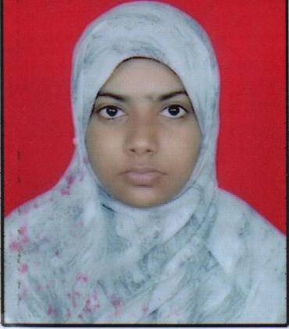
Name: Mulla
Mulla.366627@2freemail.com
Educational Qualification:
Standard | Percentage (%) Scored | Institutions
10 (2010-2011) | 69.20 | SSC (Maharashtra )
12 (2012-2013) | 45 | HSC (Maharashtra)
1st Year (BMS)(2013-2014) | 65.28 | Mumbai University
2nd Year (BMS)(2014-2015) | 54.67 | Mumbai University
3rd Year (BMS)(2015-2016) | Appearing | Mumbai University
Personal Profile:
Marital Status: Single
Place of Birth: Kalwa (Thane)
Languages Known: English, Marathi, Hindi,Urdu.
Working Experience: Completed 2 months internship in Dena Bank Shrivardhan Branch. 1 year teaching experience(Kokan Unnati Mitra Mandal Mumbai English Medium School ShRiwardhan ).
Extra Curricular Activity: Completed MSCIT, Basic Computer Course-C+,Participate in National Conference, Avishkar Research Convention, Sports, International Recognition Research Journal, Drawing competition(Intermediates, Elementary).
Hobbies: Drawing, Reading Books, Playing Chess.
Declaration:- I hereby declare that the above mentioned information is correct up to my knowledge and I bear the responsibility for the correctness of the above mentioned particulars.

