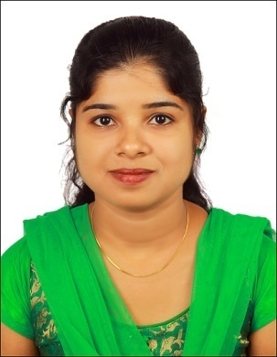
RESUME

OBJECTIVE:
To contribute my acquired knowledge, educational background and skills in a challenging position and to gain experience with a growing and dynamic firm.

EDUCATION

Master Degree in Life Science, Bachelor in Education

WORKING EXPERIENCE
- Guest Lecturer in Department of Zoology, Union Christian College, Aluva(Mahatma Gandhi University )from 13-9-2010 to 4-11-2010
- Facilitated student learning in the areas of cytology and physiology
- Supervised practical sessions in the areas of instrumentation and Bio-statistics.

- Teacher at Rajagiri Public School, Kalamassery, from June 2012- Sept 2014
- Implemented learning experience for students of primary, upper primary and senior section in the areas of science
- Facilitated teaching in classes 1st to 9th standard.
- Handled environmental science, general science and biology.
- Implemented programs to encourage student participation in teaching – learning process.
- Performed various duties both in scholastic and non scholastic areas.
PROFESSIONAL SKILLS
- Great teaching aptitude
- Thorough Knowledge of the subject to be taught
- Knowledge of utilizing all the modern teaching aids appropriately and effectively
- Proficiency in handling computer aided tools and the web platform
- Ability to create quick interests among the students about the subject
- Fluency in English and good communication skill.
- Skill of explanation
- Knowledge of common student's psychology.
SCHOLASTIC RECORDS
Name of  the course | Year | Class | Percentage of Marks | Institution | Board / University
SSLC | 2003 | Distinction | 81 | Lady of Hope Anglo Indian High School | Board of Secondary  Education
Plus Two | 2005 | Distinction | 75 | G H S S E | Board of Secondary  Education
BSc Zoology | 2008 | Distinction | 90 | St. Teresa’s  College | Mahatma Gandhi University
MSc Marine Biology (equivalent to MSc Zoology) | 2010 | Distinction | 81 | School of Marine Science , CUSAT | Cochin University of Science And Technology
B Ed | 2011 | Distinction | 95 | St. Joseph College of Teacher Education | Mahatma Gandhi University

LABORATORY EXPOSURE
- Zoology: Identification of organisms belonging to different phyla, blood smear preparation and identification of cells, dissection.
- Botany: preparing sections of root, stem, and leaf, taxonomical studies.
- Biochemistry: Qualitative and quantitative analysis of bio molecules(proteins, amino acids and carbohydrates), UV visible spectroscopy and chromatographic techniques, quantitative analysis like colorimetry, detection of abnormal constituents in urine.
- Biotechnology: PAGE, HPLC, Lyphilizer and ultra centrifugation.
- Immunology: Heamocytometer
- Ecology: Collection, identification and study of ecologically important marine organism, field trip and study of coral reef islands.
- Planktonolgy: Identification of phyto and zoo plankton

