AHMED
AHMED.366635@2freemail.com

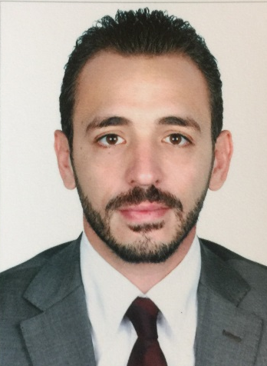 | OBJECTIVE  Seeking for a Senior Medical Rep position in your reputable company where I can utilize my competenecies and skills to achieve the company short term&long term plans. To meet the company vision and mission.  EMPLOYMENT HISTORY & EXPERIENCE:  • SANOFI GULF, DUBAI, UAE. – Senior Medical Representative  April 2011 till date.  Responsibilities & Achievement:  January 2015 till date:  - Responsible for sales & promotion of Lanzor & Enterogermina  ( ASTER & Zulekha hospital ).  - Achieving 2015 plan with 20% PPG.  - Best Achiever Semester1 2016 124% achievement.  - Team Leader assignment starting from January 2016  ( incharge of following up with 5 MR Dubai-NOE ).  August 2012 till December 2014:  - Responsible for sales & promotion of Tavanic & Xatral  (ASTER ,Prime medical center & Belhoul specialty hospital ).  - Achieving 2013 plan with 25% PPG.  - 2014 Achieving 116% Vs plan with 30% PPG.  - Sales Force excellence Award 2014, Top 10 Gulf sales champions.  April 2011 till July 2012:  - Responsible for sales & promotion of Tarivid & Flagyl.  ( NMC , Zulekha , Belhoul specialty hospital , Belhoul European hospital& RAK ).  - Achieving 2011 plan with 60% PPG.  - Achieving 2012 plan with 20% PPG.  - TABUK PHARMACEUTICALS , DUBAI, UAE. –Medical Representative  September 2010 – March 2011  - Responsible for sales and Promotion of ( Meiact , Quinox and Protec )  - Area : Bur Dubai  - GSK EGYPT , VACCINE UNIT –Product Specialist  August 2007 – August 2010  - Job Description: Responsible for promoting of Rotarix and Hibrix Vaccine  - Part of great success in Rotarix & Cervarix Launch .  - Part of great success in innovative projects “ Back to school & Syndicate Twinrix awareness program.  - Achieving 100 % in 2008.  - Best Achiever in 2009 after achieving 120% of the target in both products.  - Best Achiever in 1st semester 2010 after achieving 116 % of Rotarix and achieving 120 % of hibrix target.  ACADEMIC BACKGROUND  BACHELOR OF VETERINARY MEDICINE Bachelor Degree of Veterinary Medicine , Cairo University , 2007  TRAININGS COURSES  - World Sales Force Excellence (W S F E) for selling Skills ( GSK) ( 2009)  - Leadership & Motivation ( SANOFI ) ( 2016 )  - Assertiveness Selling skills ( SANOFI ) ( 2015 )  - Negotiations and communications Skills training( SANOFI ) ( 2014 )  - SANOFI Middle East Rep Academy (SANOFI) ( 2015)  COMPUTER & LANGUAGE LITERACY  - Fluent in using Excel, PowerPoint, Word.  - Fluent in English ( Written & speaking ).  HIGHLIGHTS OF QUALIFICATIONS  - Ability to set short term&long term plans to be aligned with the company vision and mission.  - Cross functional alignment with (clear-open) communication.  - Identification and utilization the new market opportunities to deliver good results.  - Building profitable long term relationship with different stakeholders  ( KOLs- KDMs- KAs –SUPPLIERS ) to ensure that we satisfy and anticipate there needs to keep leading position over the competitiors.  - Excellent presentation & communication skills.  - Smart working, hard, ambitious and independent.  - Able to work under stress & self-motivated.  - Ability to face & solve market & territory problems.  - Team player.

