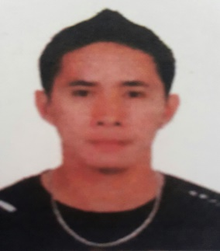
CLITO
CLITO.366650@2freemail.com

OBJECTIVE:
To join an organization where I can employ my skills and expertise, and attain a high level of performance. I have the right attitude to indisputably perform competently in any field of assignment that would be given to me, and ability to work well with others.
EDUCATIONAL BACKGROUND:
2002 Undergraduate
Bachelor of Science in Commerce
Western Institute of Technology
La Paz, Iloilo City

WORK EXPERIENCE:
REL CREDIT CORPORATION
Jalandoni St., Jaro, Iloilo City
Position: Driver/Messenger
May 25, 2008-December 30, 2016

- Determine destinations by referring to addresses on package/documents.
- Ensure that packages or messages are delivered in a time efficient manner.
- Ensure that packages/documents are ready for delivery by packing them in a safe manner.
- Take recipients signature of the receipt and compare with original signature on identification.
- Understand privacy rules and not tamper with package/document.
- Maintain records of daily visits in the log book.
- Take COD (cash on delivery) where appropriate and deposit cash into bank as instructed prior to the delivery.

BREAKTHROUGH RESTAURANT
Punta Villa, Iloilo City
Position: Waiter
February 2005-March 2006

- Present menus to guests and answer question about menu items, making recommendations upon request.
- Write guests food orders on order slips for transmittal to kitchen staff.
- Serve food and beverages to guest, and prepare or serve specialty dishes at tables as required.
- Check with guests to ensure that they are enjoying their meals and take action to correct any problems.
- Clean tables or counters after guests have finished dining.

JOLLIBEE Gaisano La Paz, Iloilo City
Freemont Foods Corporation
Position: Ryder
September 2003-December 2004

- Deliver a wide variety of items to different addresses and through different routes.
- Follow routes and time schedule.
- Collect payments.
- Inform customers about new products and services.
- Complete logs and reports
- Follow DOT regulations and safety standards.
PERSONAL DATA:
Age: 32 years old
Sex: Male
Date of Birth: May 23, 1984
Height: 5’8”
Citizenship: Filipino
Religion: Roman Catholic
Civil Status: Married
Language Proficiency: English, Tagalog

