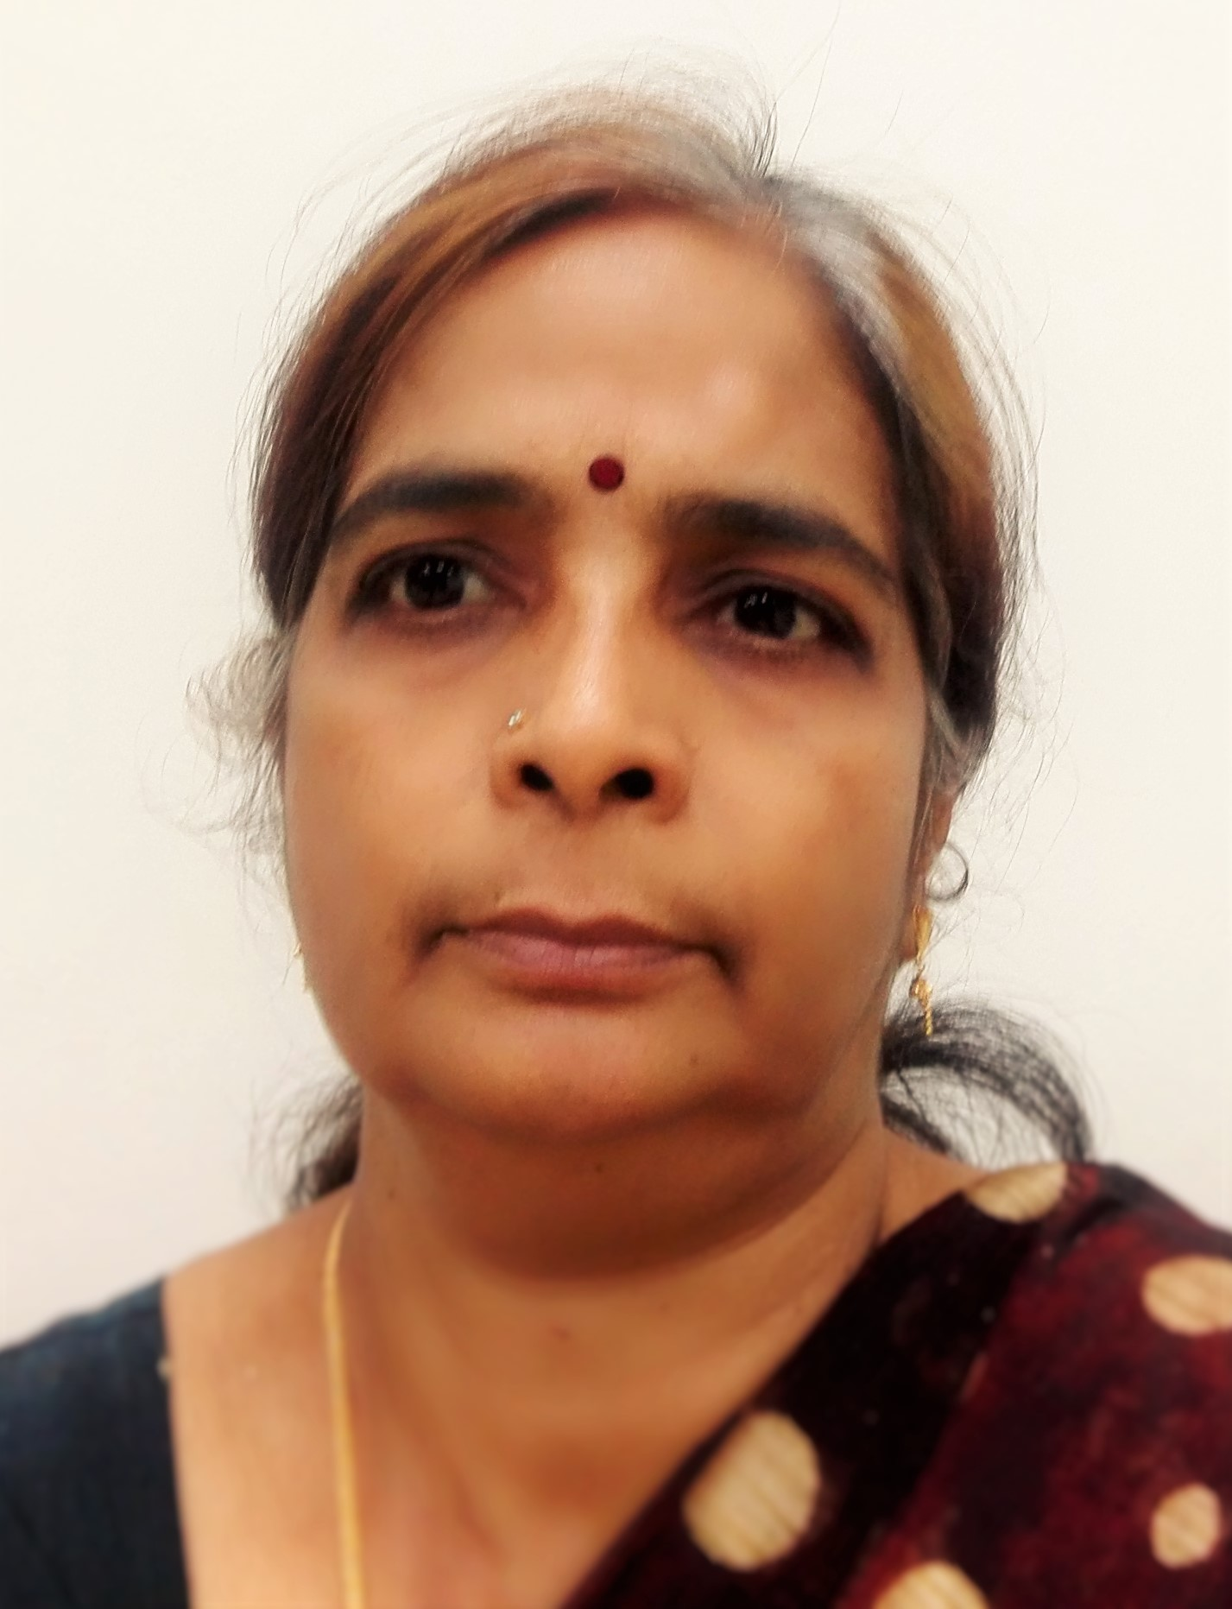C U R R I C U L U M V I T A E

Mrs. Jayashree
Jayashree.366653@2freemail.com

PGT Trained Senior Secondary Teacher with 25 years experience in Schools of CBSE & IGCSE STREAM
Presentable with good communications skills,

Career Objective

Seeking a challenging and lively Career in the field of Education in various Schools (India & UAE) where my enthusiasm and conceptual skills could be utilized and contributed to the schools

Work Experience

- Meccademia Educational Institute, Dubai – (May 2015 to November 2016)
Entrance coaching for – NEET/ AIIMS/ SAT
Worked as Biology faculty member /Senior Biology teacher coaching students for MBBS Entrance examinations- NEET/JIPMER/ NEET /SAT/ OLYMPIAD and CBSE classes
- M/s Al Ain Juniors School, Al-Ain – (Apr.1999 – Apr.2015)

- Worked as H O D of Science Department

- The School belongs to AJ group.

- The School has both Indian (CBSE) & British (IGCSE) Systems.

Job responsibilities include:

  - Preparation of Lesson Plans
  - Head of Science Department -In charge Science Department (CBSE system and British system)
  - Follow up Subordinates work- checking lesson plans, guiding /Model teacher, class observations, Book monitoring,
  - Curriculum Mapping /Curriculum construction,
  - Organizing Science Exhibitions
- Guiding students Environmental or Eco club activities, actively served
as the Quiz Coordinator in the school guiding for Inter School
competitions and organizing
  - Participated in various workshops/ seminars in UAE & Doha, Qatar
  - Served as Assistant superintendent (invigilators) for CBSE Board Examination and also as External examiner of Biology practical examination.
  - Proven record of 100% results in Biology.
  - Presented workshops in the school.
- M/s Pakistan Private Management School. – (Apr 1995 – March 1999) Federal Board of Islamabad.
Worked as Sr.Secondary Biology Teacher

- M/s.NES(NPS) , CHENNAI, India - ( 1992- 1994)-CBSE ,India

- Worked as Sr. Secondary Biology Teacher,
- 2 Years in two State Board Schools, Chennai.
- 1 Year in a Coaching Centre for MBBS/IAS Entrance.

- Faculty Member in Alpha Career Academy, Chennai
- Training Students for MBBS Entrance Examinations
- IAS Coaching for Botany & Biology as main subjects)
(AIIMS, PMT-DELHI, AFMC-PUNE, CMC-VELLORE, JIPMER, EMCET-A.P.)

Computer Skills

- Microsoft Office – MS word, Excel

Linguistic Ability

- English, Tamil (Fluent in Speaking, Reading and Writing).
- Malayalam and Hindi (speaking)

Academic Qualifications

- B.Ed – Annamalai University
- Junior Research fellowship - University of Delhi – Department of Botany,
- Registered for direct Ph.D –PL 480 project – Micropropagation of forest trees
M.Sc Botany from Presidency College (University of Madras) 1987
B.Sc Botany Major (allied - Chemistry & Zoology) S.D.N.B.Vaishnav College.

Personal Details

Nationality : Indian
Date of Birth : 31/05/1965

Sex : Female

Religion : Hindu
Marital Status : Married
Visa Status : Visit Visa (10.7.2017)
Notice Period : 1 Month
Salary Expected: Negotiable

Personal Skills

- Timely thought and meticulous planning in all sectors of responsibility.
- Take initiatives and drive comprehensive problem solving abilities.
- Ability to work in close Co-operation and harmony with others.
- Good interpersonal skills.

Declaration

I certify that the aforementioned information is correct and complete to the best of my knowledge.

