CV (curriculum vitae)

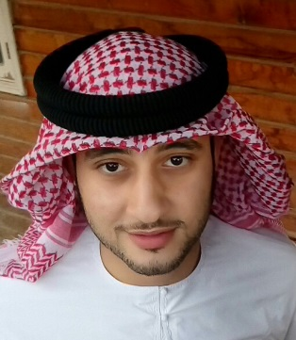Abdullah
Abdullah.366654@2freemail.com

Skills and achievements:-
- I've got good communication skills like speaking with people properly etc.
- Use Microsoft word and excel very well.
- Worked in the media office of H.H. Sheikh Hazza bin Khalifa Al Nahyan media office as a presenter for 1year.
- Worked in the Q.C department of union cement company for 1 year.
- Worked in DU Telecommunications Company as CSR (Customer Service Representative) for premium customers for 1 year.
- I was a part of the government summit support team 2015.
- Worked in the RTA (Roads & Transport Authority) as customer service for 1 Year.
- Working in Mohammed Bin Rashid Housing Establishment as customer service.

Education:-
- I'm a 2nd year student in media and journalism at university of corner stone International studies.
- Got 75% in high school and got graduated from saeed bin jubair school (Al Nakheel school)

Interests:-
- I write poets and got appreciation letter from HH sheikh Taleb Bin Saqr Bin Mohamed Al Qasimi.
- Horse riding.
- Football etc.

Other information:-
- I've got driving license (Automatic)
- I speak Arabic and English perfectly.
- My visa is employee visa.

Personal details:-
- I'm 22 years old.
- I'm Muslim.
- I'm Egyptian from Cairo and born in UAE.

