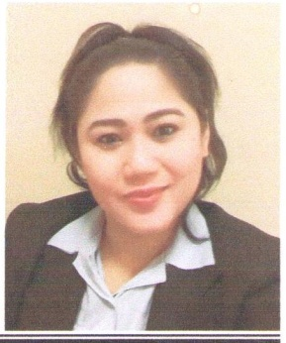
Rowena

Rowena.366665@2freemail.com

Position title: sales supervisor – customer service

Objective
To search for a position that would appropriately compliment my skills and ability and at the same time provide an opportunity for personal growth and development in my chosen endeavour.
PERSONAL BIODATA
- Date of Birth : 15/01/1979
- Nationality: Filipino
- Religion: Muslim
- Gender: Female
- Language Proficiency English(very good) Arabic(good)

Qualification
Holder of Certificate of BACHELOR OF SCIENCE
Good knowledge with computer skills

Professional Experience
CUSTOMER SERVICE :2010-TILL NOW
- Al Jaber Coin Company (Al Corniche Hospital –Danat Al Emarat – SKMC Hospital -Al Rahba Hospital- Health Point Hospital)

Duties & Responsibilities
- Answer all incoming calls to appropriate personal and the respective department
- Handle and entertain the visitors in a nice and polite way
- Assisting the visitors or clients that has appointment to personal or to the manager
- Responsible in creating the time sheet staff
- Maintain office files and dispense of control and stationeries

Sales assistant supervisor : 2007 – 2010:
- Splash shop – Al Ain

Duties & Responsibilities:
- Resolves order and inventory problems by investigating data and history , identifying alternate means for filling orders , notifying managers in customers

Assistant supervisor : 2003 – 2007
- Forever 21 ladies outfit – Philippine

Duties & Responsibilities
- Assisting and advising customer in all aspects of beauty and fragrance
- Provides products and pricing information by clarifying customer request selecting appropriate information , forwarding information and answering questions

Sales assistant : 1993-2003
Branded perfumes – duty free Philippine airport

Duties & Responsibilities
- Providing exceptional customer service
- Achieving sales targets
- Maintaining and replenishing stock
- General upkeep of the cleanliness and presentation of the store

Other Skills
- Cooperating – hilarity – hard working
- Working in order to achieve goals
- Working under pressure
- Working in a team work
- Working with different nationalities

Declaration I hereby declare that all the above furnished information’s are correct and true to the best of my knowledge.

