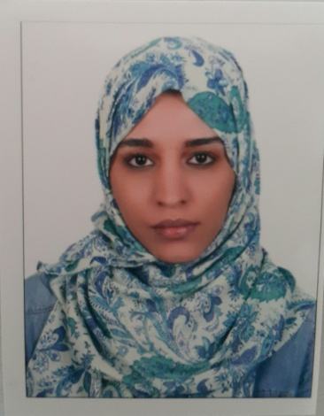
Taysier

Taysier.366702@2freemail.com

Professional Summary:
Dentist with extensive knowledge of dental procedures hygiene products, devices and solutions with a specific interest in compromised care and geriatrics hygiene care. Sever knowledge of clinical procedures, and dental terminology. Periodontics Endodontic and filling Dentistry expert.
Looking forward to taking up the responsibilities of a dentist to enhance my knowledge and skills in a reputed dental care unit.

LICENSE & REGISTRATIONS:
- UAE Ministry of health ( MOH ) license as Dental General Practitioner issued in 22_Mar_2017.
- SUDAN Medical Council permanent registration
- SUDAN Ministry of Health registration

EDUCATION:
Bachelor's degree in Dental & oral surgery, Faculty of dentistry, 6 OCTOBER university, EGYPT in 2005.

SKILLS :
- In-depth knowledge of examining x-rays, teeth straightening and filling cavities.
- Over Five years of professional experience as a GP Dentist.
- Have excellent command over written and verbal communication with patients.
- Rich knowledge of various preventive measures on teeth related diseases.
- Ability to provide effective oral hygiene techniques.
- Extensive knowledge of medical tools and equipment used in dental treatments.
- Confident in carrying out routine clinical treatments.
- Provide treatments like teeth extractions and impacted wisdom tooth extraction surgically.
- Excellent communication skills; provide detailed instruction to patients on dental care.
- Experienced in educating and counseling patients on oral healthcare
- Ability to fulfill the duty schedule roster.
- Familiar with Microsoft Word, Excel and the Internet.

Work History & experience:
- AUG 2014 – AUG 2015 : KHARTOUM DENTAL TEACHNG HOSPITAL “ General Dentist “
- AUG 2012 – AUG 2014 : BASHAYER UNIVERSITY HOSPITAL “ General Dentist “.
- MAY 2008 – MAY2009 : ANA AL SUDAN MEDICAL CENTER “ General Dentist “.
- MAY 2007 – MAY 2008 : KHARTOUM DENTAL TEACHING HOSPITAL “Dentist internship “.

Referances :
All References will be furniture upon request.

