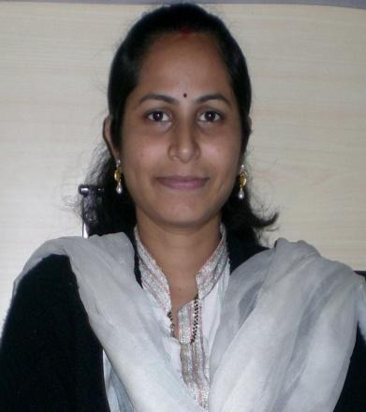
RENURAJSHEKHAR

RENURAJSHEKHAR.366703@2freemail.com

Objectives

- I am a dynamic, motivated teacher with experience in teaching early childhood learning levels.
- I have a strong interest in being involved in, and promoting, inclusive education, multicultural recognition, environmental conservation and performance arts.
- I design balanced, innovative programs that encourage students to make a positive impact on their local and global communities within the scope of current curriculum frameworks and educational models.
Excel At
- Planning and implementing lessons in accordance with state outcome statements.
- Daily classroom management, monitoring student behaviour and individual student progress.
Educational qualifications

- B.com graduate (Andhra University, NAAC A+ University, India) in the year 2010.
- Diploma in pre & primary teachers training course (American TESOL), (Montessori teachers training) in the year 2013
Teaching activities

- Zee Montessori teachers learning system
- Computer Skills: MS Office
Teaching Experience

Kidzee Pre School, Manish nagar, Nagpur during the year 2013-14

Personal Profile

Date of Birth : 09-01-1983
Marital status : Married
Nationality : Indian
Languages Known : English, Telugu, and Hindi

