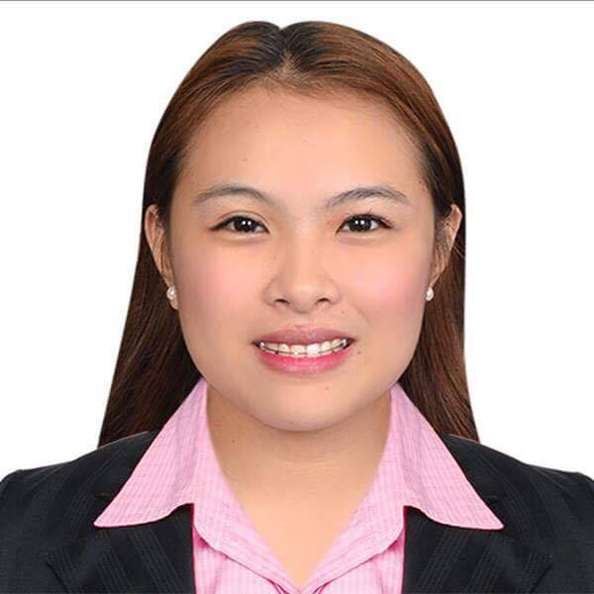
Suarez
Suarez.366706@2freemail.com

CAREER SUMMARY

Experienced English teacher with passion for both written words and teaching, uses this passion to connect students to the material. Possesses good presentation and communication skills that ensure students learn the material presented as well as they can.

Professional Experience

- ELEMENTARY TEACHER AT FRIENDS OF THE KING ACADEMY
May 30, 2015- March 31, 2017
    - Prepared unit and lesson plans for courses of study, following curriculum guidelines and common core standards.
    - Trained four student teachers in the preparation and implementation of classroom lessons and instructed them on classroom management.
    - Prepared, administered, and graded tests and assignments facilitating evaluation of students' progress and provided feedback.
    - Instructed students individually and in groups, utilizing various teaching methods.
    - Conferred with parents, guardians, teachers, counselors, and administrators in order to resolve students' behavioral and academic problems.

- HIGH SCHOOL TEACHER AT MT. MORIAH CHRISTIAN ACADEMY
May 21, 2014- March 31, 2015
- Proficient in the use of curriculum based measurement assessment systems
- Especially adept at identifying the needs of each student
- Substantial understanding of student-directed classroom management
- Superior knowledge of critical reading and mathematical principles
- Impressive communications abilities
- Excellent observational skills

Education

Tertiary Level
- National Teachers’ College
Quapo Manila
Bachelor of Secondary Education major in English
18 Units of Professional Teaching
Graduated 2016
- Polytechnic University of the Philippines
Mabini Campus, Sta. Mesa, Manila
Bachelor of Arts in English
Graduated 2014

Secondary Level
Dr. Arcadio National High School
San Martin De Porres Parańaque City
Graduated 2010

Primary Level
Bagong Tanyag Elem. School
Bagong Tanyag, Taguig City
Graduated 2006

Training & Certificate

- Licensed Professional Teacher by Professional Regulation Commission

- Convocation on the 26th DEFLL Anniversary on Korean Culture and Language with Director Seong Un Hwang
Polytechnic University of the Philippines
2013
- Retorika sa Makabagong Pagdulog sa Pagsulat ng Maikling Kuwento
Malacañang Complex, San Miguel, Manila
January 2012

Key Skills and Core Competencies
- Good communicator – Mature, patient, responsible and positive attitude.
- Approachable – Good listening skills.
- Passionate and energetic.
- Planning and organizational skills.
- Computer Expert – MS Word, PowerPoint, Excel, Internet Research

I hereby certified that the above information is true and correct to the best of my knowledge and belief.

