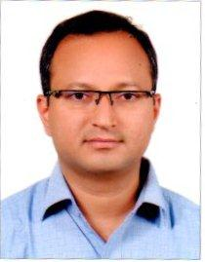
Sreekant
Sreekant.366710@2freemail.com

I am 48 years old, MBA from UK having experience of two decades in business development. Started my career with Glaxo Pharmaceuticals, after 4 years moved on to automotive industry and associated with TATA, Ford, Ashok Leyland, TVS and Mahindra. Business development assignments include domestic and international assignments. Travelled to countries like Sri Lanka, Bangladesh, Middle East Region, UK, Singapore, Malasia, Hong Kong, Macau, Germany, Hungary, South Africa and Nigeria. Worked with diverse teams and situations. Manged operations with 800 manpower in multiple locations.
Over the years, managed various business models like retail, after sales service, distribution, franchisee and dealership. Further I have also managed JV companies and matrix organisations quiet successfully reporting to Board. Currently engaged in a start up company in setting up system ,process, people, IT infrastructure and other enablers required .
Consider relationship building, people development and management, negotiation, communication, financial orientation, out of box thinking are my core skills where I have sharpened with the last 2 decades of experience and demonstrated in the assignments with results.
Have global mind-set in delivering stake holder's expectations.

