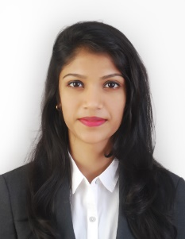
SAMANTA
SAMANTA.366730@2freemail.com

CAREER OBJECTIVE:

To seek a challenging position to commensurate with my academic qualification, personal experience and knowledge. Desire an opportunity that would offer growth both professionally and personally.

SKILL SETS

- Excellent oral and written communication skills in English, Hindi & Kannada
- Possess a pleasing personality with an ability to work within a pro-active team environment.
- Ability to work under pressure and to meet the deadlines set.
- A team player with excellent communication, analytical and problem solving skills.
- Execute all entrusted tasks with precision, honesty and willing to shoulder responsibility
- Proficient in MS Office & Internet.

ACADEMIC CREDENTIALS

Exam / Degree | Board / University | Year | Percentage
BACHELOR OF ARTS (HUMAN RESOURCE DEVELOPMENT ) | Mangalore University, Karnataka. | 2013-2016 | FIRST CLASS PASSED
LEGAL LITERACY | Mangalore University, Karnataka. | 2013 | 79%
JOURNALISM | Mangalore University, Karnataka. | 2014 | 87%
PRE-UNIVERSITY EDUCATION | Ladyhill Victoria P U College ,Mangalore, India | 2011-2013 | 59.8%
S.S.L.C | ST. Anna’s High School, Kuntikana ,Mangalore, India | 2011 | 52%

INTEREST

- Music, long drives & being a world explorer.

PERSONAL CREDENTIALS

- D.O.B: 07-12-1995
- Marital Status: Single
- VISA STATUS: FATHERS VISA
- Language Proficiency: English, Hindi, Kannada

DECLARATION

I hereby declare that the above written particulars are true to the best of my knowledge and belief.

