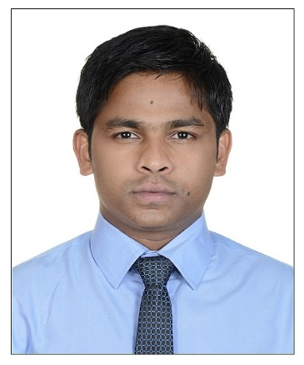

Mohammed
Mohammed.366745@2freemail.com

Personal summary:
A bright, talented and ambitious IT support technician with strong technical and accounting concepts background who possesses self-discipline and the ability to work with the minimum of supervision. Having exposure to a wide range of technologies and able to play a key role in diagnosing hardware and software problems and to ensure that quality solution meet business objectives, possessing a good team spirit, deadline oriented and having the ability to organize and present complex solutions clearly and accurately
Looking for a suitable IT support technician, customer service position with successful and dynamic company that offers room for progression, .
Professional:
CCNA, (JETKING, India’s No 1 hardware and networking institute)
Personality development certification course completed (Gems institute)
Tally ERP 9 (UP Tech software institute India)
Academic Qualification:
Secondary school R.T NAGAR PUBLIC School 2003
Higher Secondary HASANATH College 2005
Bachelor degree in finance 2008 (Indian academy college Bangalore university)

Work Experience:
RC INFO Solution
System administrator July 2008 to 2010 august
Responsible for installation and maintenance of IT equipment including printer’s scanners X-terms and workstations. Supporting end users by using remote access technologies or by visiting departments or clients.
Duties:
- Diagnosis of desktop, application, networking and infrastructure issues.
- Installation, configuration and troubleshooting of hardware and software on PC workstation
- Providing 1st /2nd line support to users
- Maintaining a log pf all problems detected and system backup
- Maintaining a regular preventive maintenance schedule
- Installing, testing operating and maintaining ip/network cctv system
Convergys India: (call center)
Technical support, January 2010-2013 august (Tele-performance call center US based) Team leader
- working for ATNT telecom group on phone support
- Technical trouble shooting
- Internet trouble shooting
- Upselling internet phone, cable, dish
- Call monitoring

HP India:
Level 1 network engineer 2013 august-2014 September
Duties:
- Installing and Configuring Various Software, According to the requirement of development team & production department
- Creating VPN Connection through ISA, Blocking Web URL, Monitoring Users web activity, allowing and denying the web request
- Diagnosing hardware and software problems, and replace defective components
- Performing data backups and disaster recovery operations
- Maintaining and administering computer networks and related computing environments, including computer hardware, systems software, applications software, and all configurations
- Planning, coordinating and implementing network security measures in order to protect data, software, and hardware
- Recommending changes to improve systems and network configurations, and determine hardware or software requirements related to such changes
- Working on Windows 2003,2008 Enterprise Edition,
- Configuring Mail client (Outlook Express, MS-Outlook 2003, 2007 & 2010 and third party tools also.)
AL-FUTTAIM (RSH ME LLC)

Currently working over 2 years

Duties:
- Third officer come cashier
- Responsible for handling brands like OSIM, puma, Nike, Adidas, UMBRO, speedo
- Main concept selling of massage chair
- Sending mails to brand managers and main office
- Monitoring individual sales and sending reports to area manager
- Following up with the customer request on phone
- Visual merchandising
- Stock management
- Receiving and sending stocks to warehouse and other location

Languages known:

- English (fluent)
- Hindi (fluent)
- Arabic (beginner)

I hereby declare that the statement and information given above is true and correct to the best of my knowledge

