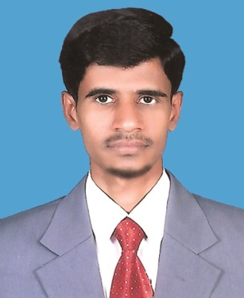

CURRICULUM VITAE

MOHAMED

MOHAMED.366748@2freemail.com

CAREER OVERVIEW
I am an enthusiastic and creative Graphic Designer with over 14 years of experience. My Strengths are in related to Design Media i.e, : Designing Posters, Brochures, Sign Boards, Business Cards, Letter Heads, Logos, etc. I am passionate to show my designing skills with a creative mind in any atmosphere. I always love to learn new things with ready to learn mentality. I enjoy meeting new challenges and utilising my time-management and organisational skills to ensure that my work is completed to strict timelines, with a high level of accuracy and attention to detail. I am committed to working to an exceptionally high standard in everything I do.

WORK EXPERIENCE AS GRAPHIC DESIGNER
3 years with Famous Printing Press, Hyderabad (1999 – 200)
2 Years in Abu Dhabi – Alain ( 2005 – 2007 )
3 years with Aijaz Printing Press, Hyderabad ( 2007 – 2009 )
4 years with Owais international printing press, Muscat, Oman ( 2010 – 2013 )
3 years Artworld graphics, Muscat, Oman. ( 2014 – 2016 )

EDUCATION
Completed Secondary School in the Year 1997

SKILLS
- Photoshop
- Illustrator
- Coreldraw
- Software Installations & System formatting
- Internet Browsing

PERSONAL INTEREST AND ACTIVITIES
- Sport (football, swimming)
- Fishing
- Listening Music
- Camping
- Travelling

LANGUAGES
- Arabic : Speaking, Reading & Speed Typing
- English: Speaking, Reading, Writing & Speed Typing
- Urdu : Speaking, Reading, Writing
- Telugu : Speaking, Reading, Writing
- Hindi : Speaking, Reading, Writing

DECLARATION

I solemnly declare that all the above information is correct to the best of my knowledge and belief.

