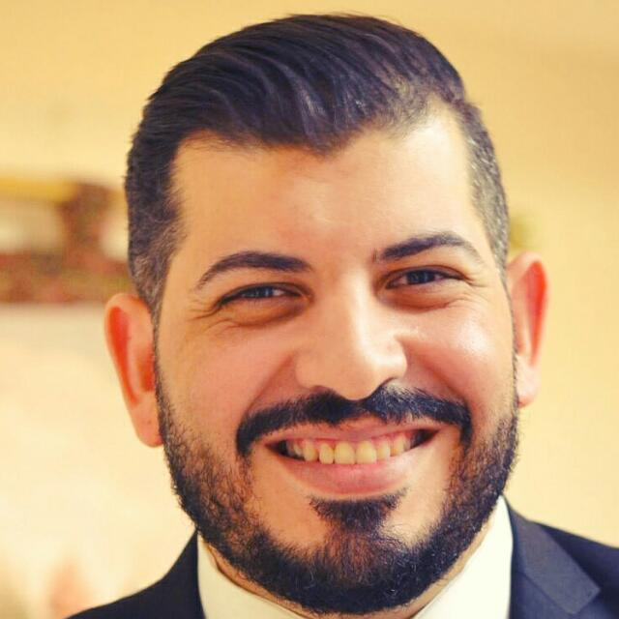 C:\Users\Ahmed El Menshawy\Desktop\SPIMACO.png



PERSONAL PROFILE

***Date of Birth*** *11th of May 1980*

***Nationality*** *Egyptian*

***Gender*** *Male*

***Marital Status*** *Married*

***Driving License*** *Present & Valid*

AHMED

[AHMED.366762@2freemail.com](mailto:AHMED.366762@2freemail.com)



WORK EXPERIENCE

**Ahmed**

***Company*** ***MedPharma - Valeant (UAE)***

***Period***  *from 2015 – NOW*

***Title***  *Field Force Supervisor*

***Lines*** *2 lines (8 team members)*

***Area***  *Dubai & N.E*

***Company*** ***SPIMACO (UAE)***

***Period***  *From 2012 – 2015*

***Title***  *Area Supervisor*

***Lines*** *PC4 & pedia line (7 team members)*

***Area***  *Dubai & N.E*

***Company*** ***SPIMACO (UAE)***

***Period***  *from December 2009 – 2012*

***Title***  *Senior Medical Representative*

***Company*** ***SPIMACO (UAE)***

***Period***  *From 2005 – 2009*

***Title***  *Medical Representative*

***Area***  *Sharjah, Bur Dubai & N.E.*

***Company*** ***SERVIER Egypt***

***Period***  *2003 - 2005*

***Title***  *Medical Representative*

***Area*** *Gharbia - Egypt*



***Company*** ***MEDPHARMA - VALEANT (UAE)***

***Period***  *From October 2015 – present*

***Title***  *Field force supervisor*

***Lines*** *Leflox & pedia line (7 team members)*

***Area***  *Dubai & N.E*

COTCT

LANGUAGES

ARABIC – MOTHER TOUNGE

ENGLISH - FLUENT

SKILLS

SALES



EDUCATION

MANAGEMENT

MARKETING

*Advanced Diploma in Marketing 2010*

Cambridge College, UAE

*Bachelors in Pharmaceutical Science 2003*

Tanta University, Egypt

MANAGEMENT

MARKETING



ARABIC – MOTHER TOUNGE

ENGLISH - FLUENT

CONTACT

LANGUAGES



ACHIEVMENTS

* *Meeting my assigned sales targets in every year since I started my career.*
* *Develop and coach some of the best achievers in companies I’ve worked for.*
* *Successful lunches for lots of main products.*
* *Introduction of company products in most of hospitals and big groups in Dubai and Northern emirates.*
* *Creating connections with most of KOLs in the territory.*

**Ahmed El Menshawy**



* *Extensive experience in sales*
* *Excellent written and verbal communication skills*
* *Strong Presentation skills*
* *Persuasiveness – Know-how to demonstrate, promote and sell*
* *Goal-oriented*
* *Strong networking skills*
* *Negotiating skills*
* *Good Judgment*
* *Decision making*
* *Leadership: An experienced team leader*
* *Influencing, leading, and delegating abilities*
* *Critical thinking, decision making and problem solving skills.*
* *Planning and organizing – Organizational abilities*
* *Result oriented: Ability to achieve the target within given time*
* *Conflict resolution.*
* *Adaptability – Efficient under pressure, always meet deadlines*
* *Excellent computer skills*

+971 55 21 40 333

*Available upon request*

REFERENCES

MARKETING

MANAGEMENT

SALES

SKILLS

[Dr_ahmed_elmenshawy@hotmail.com](mailto:Dr_ahmed_elmenshawy@hotmail.com)

[Dr.Ahmed.ElMenshawy@Gmail.com](mailto:Dr.Ahmed.ElMenshawy@Gmail.com)

Majaz 3 - Sharjah

SKILLS